|  |
| --- |
| Société Générale |
| ACI Object Allocation |
| GTS/HCS/AST |

|  |
| --- |
| Laurent DURAND, Laurent SANNA, Serge TORDO, Stéphane AUGUIER-BARAT  05/02/2019 |

Contents

1 ACI Data Model Overview 4

2 Sites and Fabric objects 5

2.1 Multisite Fabric overview 5

2.2 Site ID and Site Code 6

2.3 Site and Room Code 6

2.4 Multisite Fabric Code 7

2.5 APIC Site ID 7

2.6 APIC & Fabric Domain Name 7

2.7 Fabric Logical Entities 8

2.7.1 Overview 8

2.7.2 Logical model 9

2.7.3 ACI network centric model 10

2.7.5 Security Domains 11

2.7.6 Room urbanization & multitenancy 11

2.7.7 Entity Administrator Accounts 12

2.7.8 RBAC rules 12

2.7.9 Physical Domains and Network Domains 13

2.7.10 Server attachment methods 14

2.7.11 Server port encapsulation mode and EPG binding 18

2.7.12 Server autoconfiguration process (PXE) 20

2.8 Fabric dedicated OTV infrastructure for production flows migration purpose 21

2.8.1 Overview 21

2.8.2 N7K Nodes for OTV 21

2.8.3 N7K Virtual Device contexts and port groups 23

2.8.4 OTV site identifiers and site VLANs 30

2.9 Fabric VLAN Allocation 36

3 Fabric Node objects 37

3.1 Device Code 37

3.2 Device Naming Convention 37

4 IP Address range allocation 38

4.1 External Tunnel end points (ETEP) 38

4.2 BD GIPO IP addresses 39

4.3 Tunnel end points (TEP) 40

4.4 Out of Band 40

4.5 External Devices 41

4.6 Router ID IP address 41

4.7 Customer IP addressing and migration strategy 42

5 Service description 43

5.1 Tenants 43

5.2 VRF (Private Networks) 44

5.3 Bridge Domain (BD) 44

5.4 EPG 44

5.5 L3Out (External Routed Network) 45

6 Fabric description 46

6.1 Attachment datamodel overview 46

6.2 Generic naming convention 46

6.2.1 VLAN Pools 48

6.2.2 Domains 48

6.2.3 AAEP (Attachable Access Entity Profiles) 48

6.2.4 Interface Policy Group 49

6.2.5 Interface Profile 58

6.2.6 Interface Selector 58

6.2.7 VPC domains 60

6.2.8 Switch Profile 61

6.2.9 Switch Selector 61

6.2.10 Switch Policy Group 62

6.3 ISN Attachment 63

6.3.1 Network Interconnexion description 63

6.3.2 VLAN Pools 63

6.3.3 External Routed Domain 63

6.3.4 AAEP (Attachable Access Entity Profiles) 64

7 OTV Network 65

7.1 Overview 65

7.2 OTV interconnexion with MAN network 66

7.2.1 Local OTV for not stretched BD 66

7.2.2 Multisite OTV for stretched BD 69

8 Multisite Site Controller 71

8.1 Model Overview 71

8.2 Data Model and multi-tenancy 73

9 Fabric interconnexion 74

9.1 BGP AS Number 74

9.1.1 Overview 74

9.1.2 Multisite Workaround and BGP setup 75

9.1.3 Multisite Workarround AS numbering 78

9.1.4 Internal AS number 80

9.1.5 External AS number 80

9.2 “permit any” contract 81

9.3 OSPF Interco for ISN 82

10 Device Urbanization 86

10.1 Spine switches 86

10.1.1 Naming convention 86

10.1.2 Baby Spine nodes Generic port allocation (9364C) 87

10.1.3 8 slots Spine nodes Generic port allocation (C9508) 90

10.2 Leaf switches 93

10.2.1 Naming Convention : 93

10.2.2 Leaf nodes Generic port allocation 93

10.2.3 Border Leaf Specific Allocation 97

10.2.4 Service Leaf Specific Allocation 99

10.2.5 Customer Leaf Standard Allocation 101

10.2.6 L2DCI OTV nodes for migration purpose 102

10.2.7 APIC nodes 109

10.2.8 MSC physical nodes 111

10.2.9 MSC virtual nodes 111

11 Default QoS setup 112

12 Maintenance groups 113

13 Generic Setup 115

13.1 Syslog 115

13.2 SNMP 115

13.3 NTP 116

13.4 AAA 116

# ACI Data Model Overview

ACI is using a new network model based on :

* Service description :
  + Tenant, VRF, Bridge Domains : for fabric internal network service description
  + External Routed Networks (L3Out), Networks (External EPG), Logical Node Profiles : for external network description
  + Application Profile, End Point Groups, Static Ports : for application service description
* Fabric description :
  + Interface profiles, interface policy, AAEP, domains, vlan pools : for fabric leaf interfaces configuration
  + Switch profiles, Switch policy groups : for fabric leaf switches configuration
  + Virtual Port Channel default, Explicit VPC protection group : for fabric leaf switches VPC pair configuration



# Sites and Fabric objects

## Multisite Fabric overview



Multisite controllers will be rolled out onto following sites

|  |  |
| --- | --- |
| Multi-Site Fabric Controller | Site |
| **ALD** | DC5 |
|  |  |
| **ASSU** | DB2 |
| **RETAIL** | DC2 |
| **MARKET** | PAN |
| **PLATFORM** | DC5 |

Following fabrics are envisaged for SG Datacenters :

|  |  |  |  |  |  |  |
| --- | --- | --- | --- | --- | --- | --- |
| Multi-Site Fabric | Fabric Name | Site | #APIC | Spine Model | #rooms | E/W DC capacity |
| **ALD** | ALD-DC5-ACI-FABRIC | DC5 | 3 | 9364C | 1 | 120G |
| **ALD** | ALD-PAN-ACI-FABRIC | PAN | 3 | 9364C | 1 | 120G |
| **ASSU** | ASU-DC2-ACI-FABRIC | DC2 | 3 | 9364C | 1 | 120G |
| **ASSU** | ASU-DB2-ACI-FABRIC | DB2 | 3 | 9364C | 1 | 120G |
| **RETAIL** | RET-DC2-ACI-FABRIC | DC2 | 4 | C9508 | 1 | 120G |
| **RETAIL** | RET-DB2-ACI-FABRIC | DB2 | 3 | C9508 | 5 | 120G |
| **RETAIL** | RET-SC2-ACI-FABRIC | SC2 | 4 | C9508 | 1 | 120G |
| **RETAIL** | RET-DC5-ACI-FABRIC | DC5 | 4 | C9508 | 1 | 120G |
| **MARKET** | MKT-DC5-ACI-FABRIC | DCX | 4 | C9508 | 1 | 300G |
| **MARKET** | MKT-PAN-ACI-FABRIC | PAN | 4 | C9508 | 1 | 300G |
| **PLATFORM** | PLT-DC5-ACI-FABRIC | DC5 | 3 | C9508 | 1 | 300G |
| **PLATFORM** | PLT-PAN-ACI-FABRIC | PAN | 3 | C9508 | 1 | 300G |
| **PLATFORM** | PLT-SC2-ACI-FABRIC | SC2 | 3 | C9508 | 1 | 300G |

## Site ID and Site Code

One Site ID and one Site Code is allocated for each Datacenter.

* Site ID range : 01 ... 127
* Site Code range : AA0 ... ZZ9

|  |  |  |
| --- | --- | --- |
| Datacenter | Site Code | Site ID |
| Marcoussis DC2 | DC2 | 01 |
| Marcoussis DB2 | DB2 | 02 |
| Marcoussis DC5 | DC5 | 03 |
| Equinix Pantin | PAN | 04 |
| Seclin 2 | SC2 | 05 |
| Marcoussis DCX | DCX | 06 |

## Site and Room Code

Some Datacenter are organized in several rooms. A three characters room code will be allocated for each room. When a site has only one room, we will use COM for this unique room.

|  |  |  |
| --- | --- | --- |
| Datacenter | Room | Room Code |
| Marcoussis DC2 | 2A1 | 2A1 |
| Marcoussis DC2 | 2A2 | 2A2 |
| Marcoussis DC2 | 2A3 | 2A3 |
| Marcoussis DC2 | 2A4 | 2A4 |
| Marcoussis DC2 | 2B1 | 2B1 |
| Marcoussis DB2 | B2D | B2D |
| Marcoussis DC5 | 5B1 | 5B1 |
| Equinix Pantin | DH15 | DH15 |
| Seclin 2 | Azimov | AZV |
| Seclin 2 | Barjavel | BAL |
| Marcoussis DCX | COM | COM |

## Multisite Fabric Code

A three letters fabric code will be assigned to each SG Multisite Fabric.

* Fabric Code range : AAA ... ZZZ

|  |  |  |  |
| --- | --- | --- | --- |
| Multi-Site Fabrics | Fabric Code | Multi Site ID | Tenants |
| ASSU | ASU | 01 | ASSU |
| RETAIL | RET | 02 | BDDF, CDN, BSC |
| ALD | ALD | 04 | ALD |
| MARKET | MKT | 05 | SGCIB, SGSS |
| PLATFORM | PLT | 06 | PLATFORM |

A Multi-Site Fabric ID is also assigned in order to be used when string are not supported.

## APIC Site ID

One Fabric Site ID has allocated for each fabric element into a Multisite Fabric.

* Site ID range : 1 ... 127

Note: Each Fabric will have a Fabric ID = 1.

|  |  |  |  |  |  |  |
| --- | --- | --- | --- | --- | --- | --- |
| Multi-Site Fabrics | DC2 | DB2 | DC5 | PAN | SC2 | DCX |
| ASSU | 1 | 2 |  |  |  |  |
| RETAIL | 1 | 2 | 3 |  | 5 |  |
| ALD |  |  | 3 | 4 |  |  |
| MARKET |  |  |  | 4 |  | 6 |
| PLATFORM |  |  | 3 | 4 | 5 |  |

## APIC & Fabric Domain Name

Domain name is a 6 letter code : <Fabric Code><Site Code>

* <Fabric Code>: 3 letters fabric code
* <Site Code>: 3 letters site code

|  |  |  |  |  |  |  |
| --- | --- | --- | --- | --- | --- | --- |
| Multi-Site Fabrics | DC2 | DB2 | DC5 | PAN | SC2 | DCX |
| ASSU | ASUDC2 | ASUDB2 |  |  |  |  |
| RETAIL | RETDC2 | RETDB2 | RETDC5 |  | RETSC2 |  |
| ALD |  |  | ALDDC5 | ALDPAN |  |  |
| MARKET |  |  |  | MKTPAN |  | MKTDCX |
| PLATFORM |  |  | PLTDC5 | PLTPAN | PLTSC2 |  |

## Fabric Logical Entities

### Overview

On some physical fabrics, several entities could be hosted. The table below is giving the initial logical split planned at the service activation :

|  |  |  |
| --- | --- | --- |
| Fabric | Entity | Description |
| **ALD** | ALD | ALD entity services dedicated hosting |
| **ASSU** | ASSU | ASSU entity services dedicated hosting |
| **RETAIL** | BDDF | SG Retail Banking services dedicated hosting |
| CDN | Credit Du Nord Retail Banking services dedicated hosting |
| BSC | Group Business Solution Center services dedicated hosting |
| **MARKET** | SGCIB | SG Corporate & Investment Banking services dedicated hosting (MARK, GLFI, CORI..) |
| SGSS | SG Securities Services entity services dedicated hosting |
| CGA | Compagnie Générale d’Affacturage |
| **PLATFORM** | CLOUD | SG Private Cloud services dedicated hosting |
| WORKPLACE | SG Workplace services dedicated hosting |
| BIGDATA | SG BIGDATA shared infrastructure |
| SHARED | Any generic transversal services dedicated hosting |

Each logical entity will be bound to a given subset of leaf nodes.



### Logical model

In order to be able to split a physical fabric into several entities we will implement a specific logical model :

* 1 tenant per entity
* 1 global tenant for shared network function (MAN, Loadbalancer and Firewall device interconnexion)
* dedicated maintenance groups for each entity
* dedicated physical domains bound to all physical leaf switches of a given entity
* security domains with RBAC (Role Based Access Control) rules



/!\ : port binding is also made with MSC. RBAC rules on port binding are not enforced at MSC level (**RBAC rules enforced at APIC level are useless**).

### ACI network centric model

VLANs are broadcast domains that allow frames to be sent out all ports of a switch tagged with that VLAN, if the frame has no awareness of the destination. This is called flooding.

VLANs are generally mapped to one subnet. For example, SG may have VLAN 21 which contains all of database servers. It is likely that these servers will only be assigned to one subnet, perhaps 192.168.21.0/24.

Usually a black list model is used, meaning that traffic is allowed by default within subnets.   
Security rules are typically assigned at the Layer 3 boundary or default gateway using Access Control Lists (ACL) or Firewall rules.

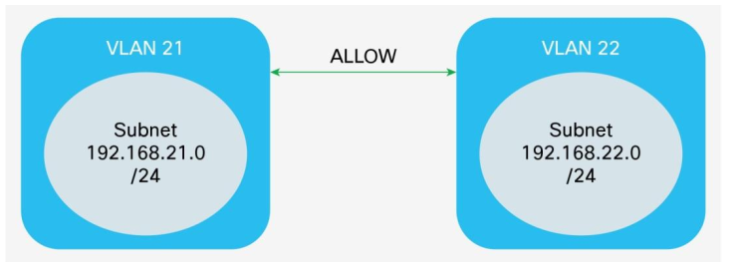

With ACI network centric model we are using following rules :

* Only one EPG per Bridge Domain
* One IP subnet per Bridge Domain
* Each bridge domain is bound to only one VLAN
* An “allow all” relationship between all EPG inside a same VRF

**Network centric** : 1 subnet = **1 Bridge domain ⬄ 1 VLAN ⬄ 1 EPG**

With this model we have no VLAN overlap inside a the fabric (1 VLAN = 1 BD) and we can use following ACI features :

* Switch Wide VLAN significance
* VLAN binding at AAEP level (for Cloud Servers)
* EPG and Bridge Domain naming convention is based on VLAN ID

/!\: With this model **no VLAN overlap is allowed into the multisite Fabric** as the BD and the EPG names have to be unique thorough the whole fabric, in order to be managed by the MSC for the whole multisite fabric.

### Security Domains

One security domain will be created for each logical entity.

|  |  |  |
| --- | --- | --- |
| Fabric | Entity | Security Domain |
| **ALD** | ALD | SD_ALD |
| **ASSU** | ASSU | SD_ASSU |
| **RETAIL** | BDDF | SD_BDDF |
| CDN | SD_CDN |
| BSC | SD_BSC |
| **MARKET** | SGCIB | SD_SGCIB |
| SGSS | SD_SGSS |
| CGA | SD_CGA |
| **PLATFORM** | CLOUD | SD_CLOUD |
| WORKPLACE | SD_WORKPLACE |
| BIGDATA | SD_BIGDATA |
| SHARED | SD_SHARED |

Security Domains are configured under: Admin 🡪 AAA 🡪 Security Management 🡪 Security Domains

### Room urbanization & multitenancy

Each tenant will get some racks and switches assigned. A proper tenant rack and switch allocation plan has to be maintained.



### Entity Administrator Accounts

A specific administrator account will be created for each entity hosted on a given fabric.

|  |  |  |  |  |  |
| --- | --- | --- | --- | --- | --- |
| Fabric | Entity | Account | Security Domain | Role | Privilege |
| **ALD** | ALD | ADMIN_ALD | SD_ALD | admin | write |
| **ASSU** | ASSU | ADMIN_ASSU | SD_ASSU | admin | write |
| **RETAIL** | BDDF | ADMIN_BDDF | SD_BDDF | admin | write |
| CDN | ADMIN_CDN | SD_CDN | admin | write |
| BSC | ADMIN_BSC | SD_BSC | admin | write |
| **MARKET** | SGCIB | ADMIN_SGCIB | SD_SGCIB | admin | write |
| SGSS | ADMIN_SGSS | SD_SGSS | admin | write |
| CGA | ADMIN_CGA | SD_CGA | admin | write |
| **PLATFORM** | CLOUD | ADMIN_CLOUD | SD_CLOUD | admin | write |
| WORKPLACE | ADMIN_WORKPLACE | SD_WORKPLACE | admin | write |
| BIGDATA | ADMIN_BIGDATA | SD_BIGDATA | admin | write |
| SHARED | ADMIN_SHARED | SD_SHARED | admin | write |

### RBAC rules

Each single Leaf node will be allocated to a single logical entity. For each Leaf switch allocated to a given entity a set of rules have to been created to allow each single switch and each single port of each switch to be managed by the entity administrator account.

|  |  |  |
| --- | --- | --- |
| Security Domain | DN | Allow writes |
| **<SEC_DOMAIN>** | topology/pod-**<POD ID>**/node-**<LEF-ID>**  topology/pod-**<POD ID>**/paths-**<LEF-ID>**/pathep-[eth**1**/**1**]  topology/pod-**<POD ID>**/paths-**<LEF-ID>**/pathep-[eth**1**/**2**]  ..  topology/pod-**<POD ID>**/paths-**<LEF-ID>**/pathep-[eth**1**/**48**]  topology/pod-**<POD ID>**/paths-**<LEF-ID>**/pathep-<PC or VPC> | Yes |

With :

* **<SEC_DOMAIN> :** Entity Security Domain
* **<POD ID> :** POD Identifier
* **<LEF-ID> :** Leaf switch Identifier

One rule per switch has to be created : topology/pod-**<ID>**/node-**<LEF-ID>**

One rule per switch port has to be created : topology/pod-**<ID>**/paths-**<LEF-ID>**/pathep-[eth**X**/**Y**]

One rule per switch PC and or VPC port has to be created : topology/pod-**<ID>**/paths-**<LEF-ID>**/pathep-<PC or VPC>

Border and service leaves are mutualized between all entities and binding won’t be delegated to any entity. They must not be listed in entity RBAC rules.

/!\ : port binding is also made with MSC. RBAC rules on port binding are not enforced at MSC level (**RBAC rules enforced at APIC level are useless**).

### Physical Domains and Network Domains

A specific physical domain will be allocated to each entity to manage the connectivity of all its compute nodes. A specific network domain will be allocated to each entity to manage the connectivity of all its network function nodes (Firewall and Load Balancers).

|  |  |  |  |  |
| --- | --- | --- | --- | --- |
| Fabric | Tenant | Physical Domain | Network Domain | Security Domain |
| **ALD** | ALD | PDOM_ALD | L3DOM_ALD | SD_ALD |
| **ASSU** | ASSU | PDOM_ASSU | L3DOM_ASSU | SD_ASSU |
| **RETAIL** | BDDF | PDOM_BDDF | L3DOM_BDDF | SD_BDDF |
| CDN | PDOM_CDN | L3DOM_CDN | SD_CDN |
| BSC | PDOM_BSC | L3DOM_BSC | SD_BSC |
| **MARKET** | SGCIB | PDOM_SGCIB | L3DOM_SGCIB | SD_SGCIB |
| SGSS | PDOM_SGSS | L3DOM_SGSS | SD_SGSS |
| CGA | PDOM_CGA | L3DOM_CGA | SD_CGA |
| **PLATFORM** | CLOUD | PDOM_CLOUD | L3DOM_CLOUD | SD_CLOUD |
| WORKPLACE | PDOM_WORKPLACE | L3DOM_WORKPLACE | SD_WORKPLACE |
| BIGDATA | PDOM_BIGDATA | L3DOM_BIGDATA | SD_BIGDATA |
| SHARED | PDOM_SHARED | L3DOM_SHARED | SD_SHARED |
| **All** | COMMON | PDOM_COMMON | L3DOM_COMMON | - |

A global physical domain will be also configured on all fabric in order to manage the connectivity of all network elements that are shared between all entities (MAN VRF interconnexion for instance) and that will be created in COMMON tenant.

Per entity fabric logical split :



### Server attachment methods

Two kinds of binding methods will be used into SG ACI fabrics :

* EPG Static Path Binding
* EPG VLAN binding at AAEP level

**EPG Static Path Binding**

With EPG Static Path Binding each set [Leaf, Port, VLAN, Encapsulation mode] have to be listed into the EPG. If several ports are participating to a same EPG they all have to be listed one by one into the EPG static port list.



**EPG VLAN binding at AAEP level**

With EPG VLAN binding at AAEP each set [EPG, VLAN, Encapsulation mode] have to be listed into the AAEP. **All ports of belonging to the AAEP** will be bound to the EPG using the same VLAN. **No VLAN overlapping is allowed** with this mode into a given AAEP.



#### Servers attachment – static path binding method

With “**EPG Static Path Binding”** we are configuring static VLAN encap on some interfaces in order to connect them one by one to a given EPG. **“EPG Static Path Binding”** is managed at tenant level :

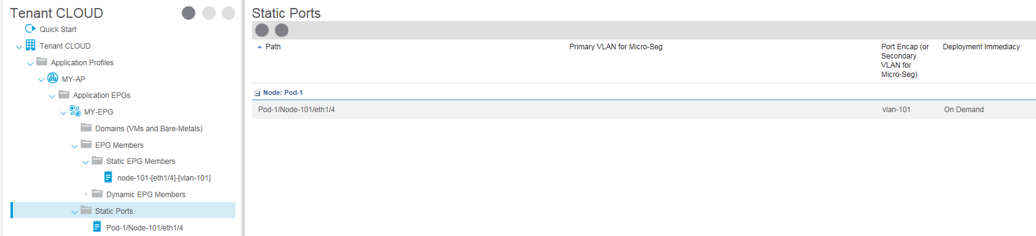

|  |  |  |  |  |
| --- | --- | --- | --- | --- |
| Fabric | Tenant | Physical Domain | AAEP | Binding Method |
| **ALD** | ALD | PDOM_ALD | AEP_ALD_COMPUTE | EPG Static Path |
| **ASSU** | ASSU | PDOM_ASSU | AEP_ASSU_COMPUTE | EPG Static Path |
| **RETAIL** | BDDF | PDOM_BDDF | AEP_BDDF_COMPUTE | EPG Static Path |
| CDN | PDOM_CDN | AEP_CDN_COMPUTE | EPG Static Path |
| BSC | PDOM_BSC | AEP_BSC_COMPUTE | EPG Static Path |
| **MARKET** | SGCIB | PDOM_SGCIB | AEP_SGCIB_COMPUTE | EPG Static Path |
| SGSS | PDOM_SGSS | AEP_SGSS_COMPUTE | EPG Static Path |
| CGA | PDOM_CGA | AEP_CGA_COMPUTE | EPG Static Path |
| **PLATFORM** | WORKPLACE | PDOM_WORKPLACE | AEP_WORKPLACE_COMPUTE | EPG Static Path |
| BIGDATA | PDOM_BIGDATA | AEP_BIGDATA_COMPUTE | EPG Static Path |
| SHARED | PDOM_SHARED | AEP_SHARED_COMPUTE | EPG Static Path |
| **All** | COMMON | PDOM_COMMON | AEP_COMMON_COMPUTE | EPG Static Path |

#### Servers attachment – binding at AAEP level (per VLAN)

In order to avoid configuring **EPG Static Path Binding** for every server interface (to all any server to connect to any VLAN), the Compute **AAEP** could be associated with all the EPG’s/VLAN’s that are required to be presented to all interfaces belonging to the given AAEP. This kind of configuration is managed at fabric level :

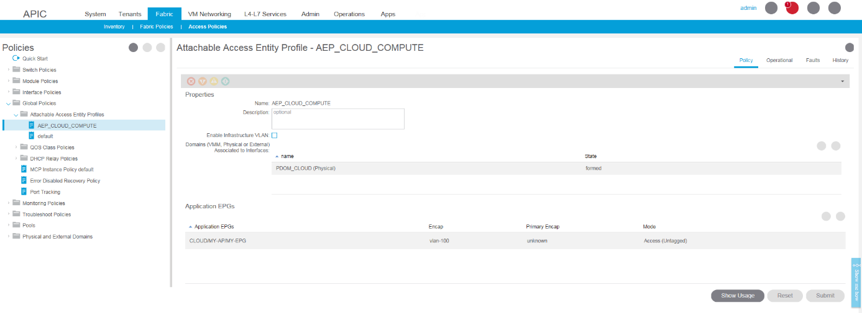

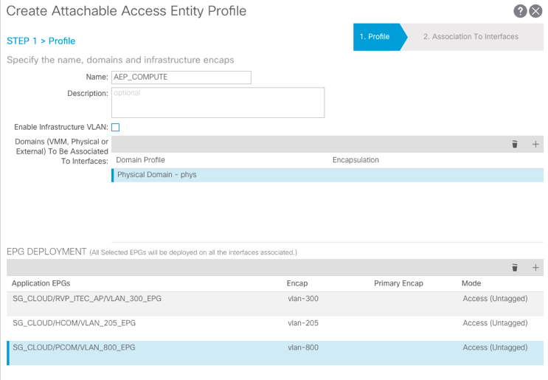

***Compute AAEP***

***All EPG/VLAN’s***

***To be available***

***To all Server POD’s***

|  |  |  |  |  |
| --- | --- | --- | --- | --- |
| Fabric | Tenant | Physical Domain | AAEP | Binding Method |
| **PLATFORM** | CLOUD | PDOM_CLOUD | AEP_CLOUD_COMPUTE | AAEP (per VLAN) |

/!\ : No VLAN overlapping allowed inside Cloud Tenant as each VLAN is globally bound on all the switches associated with Cloud Tenant.

### Server port encapsulation mode and EPG binding

3 encapsulation modes are supported when a port is bound to an EPG :

* Access (Untagged)
* Access (802.1p)
* Trunk

Following mode are used in SG Fabrics :

|  |  |
| --- | --- |
| Encapsulation mode | Allowed Mode on SG networks |
| Access (Untagged) | **No** |
| Access (802.1p) | **Yes** |
| Trunk | **Yes** |

Access (Untagged) and Access (802.1p) modes are very closed. Differences are :

* When Access (Untagged) mode is used, all ports bound to into an EPG must only use Access (untagged) mode
* When Access (802.1p) mode is used with *Generation 1 ports*, if the port has other (tagged) VLANs deployed along with an untagged EPG, then traffic from that EPG is zero tagged.

But, when EPGs are deployed on *Generation 2 ports* configured with either Untagged or 802.1p mode:

* On egress, traffic is always untagged on a node where this is deployed.
* The port accepts ingress traffic that is untagged, tagged, or in 802.1p mode

VLAN Mode Combinations Supported for Multiple EPGs :

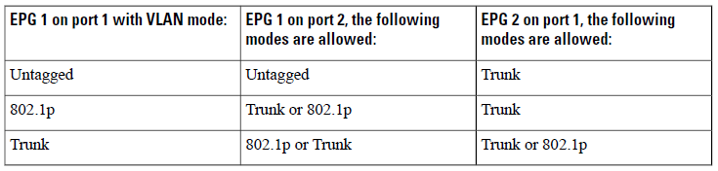

In SG ACI implementation only following combinations will be allowed :

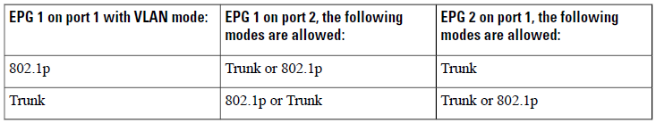

So it will possible to mix tagged and untagged traffic inside a same EPG.

**/!\: Access (Untagged) encapsulation mode must not be used. We must use Access (802.1p) encapsulation mode instead.**

**EPG Static Path Binding**

Encapsulation mode is defined into EPG/static ports folder for each port :

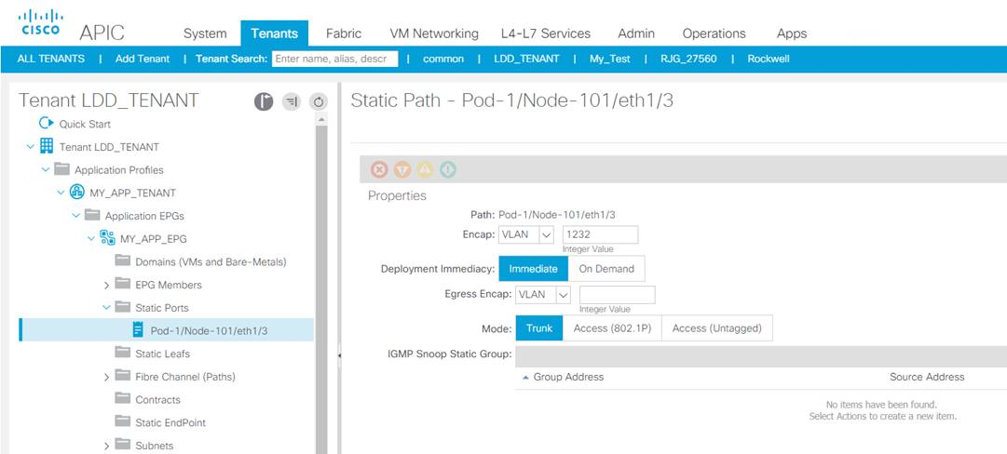

**EPG VLAN binding at AAEP level & Encapsulation mode**

Encapsulation mode is defined into AAEP folder for each EPG. All ports into the given AAEP will be bound to this EPG for a given VLAN encapsulation :

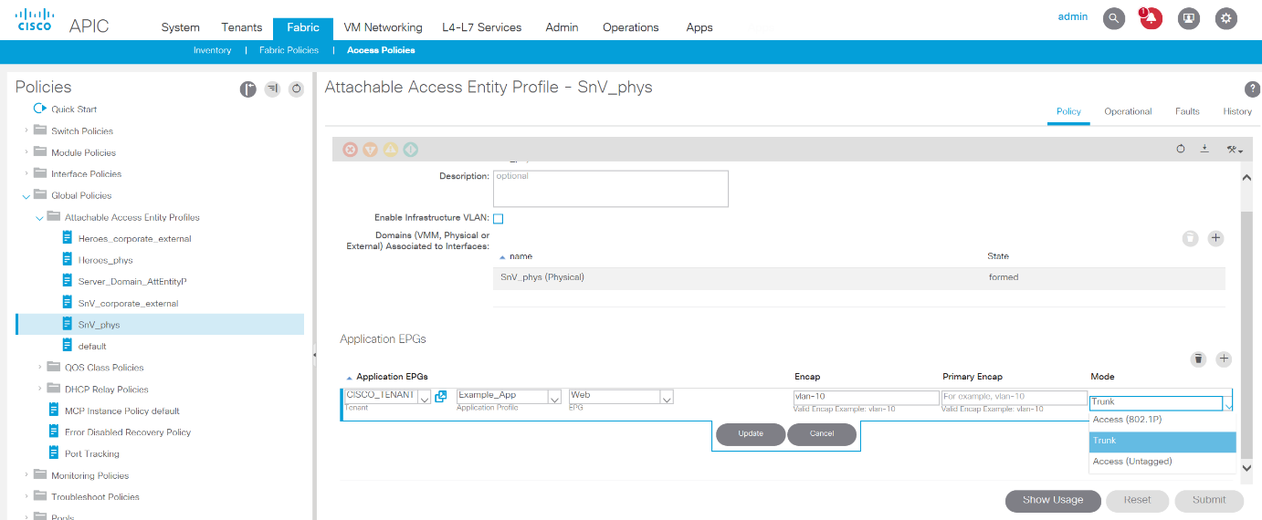

### Server autoconfiguration process (PXE)

In a first step the server is using only untagged traffic :



In a second step, once server is configured, it will used tagged traffic :



With ACI there is no need to change switch port configuration between the two steps. 802.1p mode and trunk more attachments can be used simultaneously:



/!\ : A MAC move will occur into management EPG from untagged to tagged endpoint after server autoconfiguration process.

/!\: User EPG bindings are configured at AAEP level.

**/!\: Management EPG binding is configured at static port level. First using 802.1p mode, then using trunk mode. This change has to be done manually or using an automation script**

## Fabric dedicated OTV infrastructure for production flows migration purpose

### Overview

A specific OTV network used for production flows migration will be built for each fabric and will be made up of :

* Central OTV nodes : 2 x Nexus 7706 on central sites (new DC)
* Remote OTV nodes : Nexus 7702 on remote sites (legacy DC)



Each ACI device is named according following naming convention:

New ACI infrastructure side :

<Fabric Code>-N7K-<Site Code>-<Room Code>-200**1**

<Fabric Code>-N7K-<Site Code>-<Room Code>-200**2**

Legacy infrastructure side :

<Fabric Code>-N7K-<Site Code>-<Room Code>-200**3**

<Fabric Code>-N7K-<Site Code>-<Room Code>-200**4**

* <Fabric Code> : 3 characters
* <Device Code> : 3 characters
* <Site Code> : 3 characters
* <Room Code>: 3 characters

### N7K Nodes for OTV

**OTV Nodes New DC Sites** :

|  |  |  |
| --- | --- | --- |
| Site | OTV router Hosting area | OTV Nodes |
| DC2 | ASSU | ASU-N7K-DC2-<Room Code>-200**1**  ASU-N7K-DC2-<Room Code>-200**2** |
| DB2 | ASSU | ASU-N7K-DB2-<Room Code>-200**1**  ASU-N7K-DB2-<Room Code>-200**2** |
| DC5 | PLATFORM | PLT-N7K-DC5-<Room Code>-200**1**  PLT-N7K-DC5-<Room Code>-200**2** |
| PAN | PLATFORM | PLT-N7K-PAN-<Room Code>-200**1**  PLT-N7K-PAN-<Room Code>-200**2** |
| SC2 | PLATFORM | PLT-N7K-SC2-<Room Code>-200**1**  PLT-N7K-SC2-<Room Code>-200**2** |
| PAN | MARKET | MKT-N7K-PAN-<Room Code>-200**1**  MKT-N7K-PAN-<Room Code>-200**2** |
| DCX | MARKET | MKT-N7K-DCX-<Room Code>-200**1**  MKT-N7K-DCX-<Room Code>-200**2** |
| DC2 | RETAIL | RET-N7K-DC2-<Room Code>-200**1**  RET-N7K-DC2-<Room Code>-200**2** |
| DB2 | RETAIL | RET-N7K-DB2-<Room Code>-200**1**  RET-N7K-DB2-<Room Code>-200**2** |
| SC2 | RETAIL | RET-N7K-SC2-<Room Code>-200**1**  RET-N7K-SC2-<Room Code>-200**2** |
| DC5 | RETAIL | RET-N7K-DC5-<Room Code>-200**1**  RET-N7K-DC5-<Room Code>-200**2** |
| DC5 | ALD | ALD-N7K-DC5-<Room Code>-200**1**  ALD-N7K-DC5-<Room Code>-200**2** |
| PAN | ALD | ALD-N7K-PAN-<Room Code>-200**1**  ALD-N7K-PAN-<Room Code>-200**2** |

**OTV Nodes Legacy DC Sites** :

|  |  |  |  |
| --- | --- | --- | --- |
| Site | Fabric | Site | OTV Nodes |
| ORLEANS | ASSU | Orléans Alexandrin  Orléans Campus | ASU-N7K-ORL-<Room Code>-200**3**  ASU-N7K-ORL-<Room Code>-200**4** |
| TIGERY | RETAIL | Tigery | RET-N7K-TIG-<Room Code>-200**3**  RET-N7K-TIG-<Room Code>-200**4** |
| TIGERY | MARKET | Tigery | MKT-N7K-TIG-<Room Code>-200**3**  MKT-N7K-TIG-<Room Code>-200**4** |
| CLICHY | MARKET | Orion  Aquilla | MKT-N7K-CLI-<Room Code>-200**3**  MKT-N7K-CLI-<Room Code>-200**4** |
| CLICHY | PLATFORM | Orion  Aquilla | PLT-N7K-CLI-<Room Code>-200**3**  PLT-N7K-CLI-<Room Code>-200**4** |
| SECLIN2 | RETAIL | Seclin 2 | RET-N7K-SC2-<Room Code>-200**3**  RET-N7K-SC2-<Room Code>-200**4** |
| SECLIN2 | PLATFORM | Seclin 2 | PLT-N7K-SC2-<Room Code>-200**3**  PLT-N7K-SC2-<Room Code>-200**4** |
| DC2 | RETAIL | DC2 | RET-N7K-DC2-<Room Code>-200**3**  RET-N7K-DC2-<Room Code>-200**4** |
| DC2 | ASSU | DC2 | ASU-N7K-DC2-<Room Code>-200**3**  ASU-N7K-DC2-<Room Code>-200**4** |
| DC2 | PLATFORM | DC2 | PLT-N7K-DC2-<Room Code>-200**3**  PLT-N7K-DC2-<Room Code>-200**4** |

### N7K Virtual Device contexts and port groups

Physical interfaces can be assigned to a VDC with a high degree of freedom. However, there are differences among different I/O modules because of the way the VDC feature is enforced at the hardware level. The easy way to learn the specific capabilities of the installed hardware is by entering the show interface x/y capabilities command to see the port group associated with a particular interface.

Gigabit Ethernet module interfaces belonging to the **same port group** must be assigned to the **same VDC**.

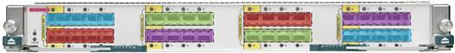

#### N7K Virtual Device Contexts on new sites

In slot 1 we will install a 24 x 40G line card and in slot 2 we will install a 48 x 10G line card. Port groups also called SOC (System on Chip) are arranged as described in following diagrams :

**40G line card** :

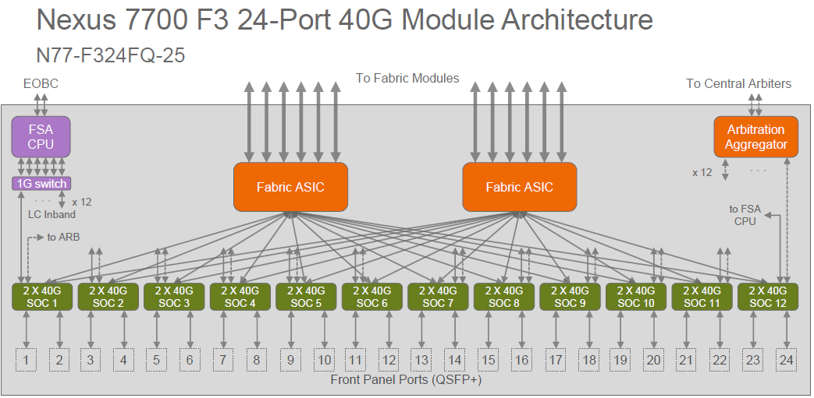

**10G line card :**

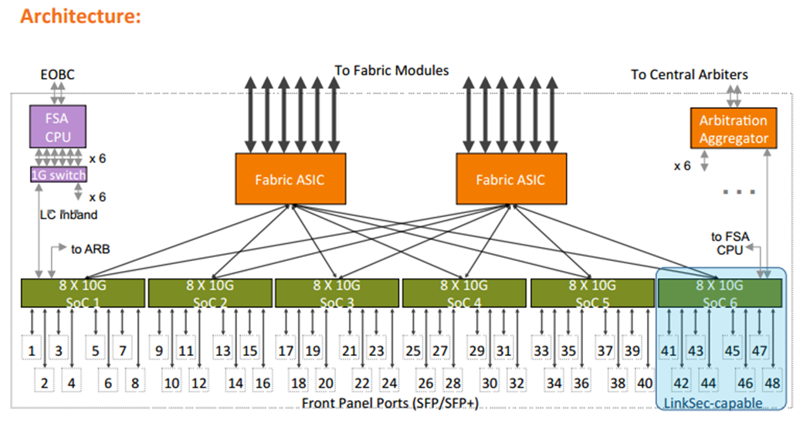

**First Central Site**



|  |  |  |  |
| --- | --- | --- | --- |
| N7K Node | VDC Name | VDC ID | Description |
| N7K-1 | LOCAL_OTV | 1 | OTV for local only BD |
| N7K-1 | MSITE_ROUTING | 3 | Multisite and Multicast routing Workaround |
| N7K-1 | LOCAL_ROUTING | 4 | Single Site Unicast & Multicast routing Workaround |
| N7K-2 | LOCAL_OTV | 1 | OTV for local only BD |
| N7K-2 | MSITE_OTV | 2 | OTV for stretched BD |
| N7K-2 | LOCAL_ROUTING | 4 | Single Site Unicast & Multicast routing Workaround |

Due to a whole port-group must be allocated to a VDC, we will have following ports allocation for each VDC :

|  |  |  |
| --- | --- | --- |
| N7K Node | VDC Name | Ports Allocation |
| N7K-1 | LOCAL_OTV | 40G : 1/1, 1/2  10G: 2/1 to 2/8 |
| N7K-1 | MSITE_ROUTING | 40G : 1/3, 1/4  10G: 2/9 to 2/16 |
| N7K-1 | LOCAL_ROUTING | 40G : 1/5, 1/6  10G: 2/17 to 2/24 |
| N7K-2 | LOCAL_OTV | 40G : 1/1, 1/2  10G: 2/1 to 2/8 |
| N7K-2 | MSITE_OTV | 40G : 1/3, 1/4  10G: 2/9 to 2/16 |
| N7K-2 | LOCAL_ROUTING | 40G : 1/5, 1/6  10G: 2/17 to 2/24 |

**Second Central Site**



|  |  |  |  |
| --- | --- | --- | --- |
| N7K Node | VDC Name | VDC ID | Description |
| N7K-1 | LOCAL_OTV | 1 | OTV for local only BD |
| N7K-1 | MSITE_OTV | 2 | OTV for stretched BD |
| N7K-1 | LOCAL_ROUTING | 4 | Single Site Unicast & Multicast routing Workaround |
| N7K-2 | LOCAL_OTV | 1 | OTV for local only BD |
| N7K-2 | MSITE_ROUTING | 3 | Multisite and Multicast routing Workaround |
| N7K-2 | LOCAL_ROUTING | 4 | Single Site Unicast & Multicast routing Workaround |

Due to a whole port-group must be allocated to a VDC, we will have following ports allocation for each VDC :

|  |  |  |
| --- | --- | --- |
| N7K Node | VDC Name | Ports Allocation |
| N7K-1 | LOCAL_OTV | 40G : 1/1, 1/2  10G: 2/1 to 2/8 |
| N7K-1 | MSITE_OTV | 40G : 1/3, 1/4  10G: 2/9 to 2/16 |
| N7K-1 | LOCAL_ROUTING | 40G : 1/5, 1/6  10G: 2/17 to 2/24 |
| N7K-2 | LOCAL_OTV | 40G : 1/1, 1/2  10G: 2/1 to 2/8 |
| N7K-2 | MSITE_ROUTING | 40G : 1/3, 1/4  10G: 2/9 to 2/16 |
| N7K-2 | LOCAL_ROUTING | 40G : 1/5, 1/6  10G: 2/17 to 2/24 |

#### N7K Virtual Device Contexts on legacy sites (independent site – no L2DCI used)

This use case has to be used when we are migrating a single site infrastructure to a multisite target.



|  |  |  |  |
| --- | --- | --- | --- |
| N7K Node | VDC Name | VDC ID | Description |
| N7K-3 | LOCAL_OTV | 1 | OTV for local only BD |
| N7K-3 | MSITE_OTV | 2 | OTV for stretched BD |
| N7K-4 | LOCAL_OTV | 1 | OTV for local only BD |
| N7K-4 | MSITE_OTV | 2 | OTV for stretched BD |

Due to a whole port-group must be allocated to a VPC, we will have following ports allocation for each VPC :

|  |  |  |
| --- | --- | --- |
| N7K Node | VDC Name | Ports Allocation |
| N7K-3 | LOCAL_OTV | 10G: 1/1 to 1/8 |
| N7K-3 | MSITE_OTV | 10G: 1/9 to 1/16 |
| N7K-4 | LOCAL_OTV | 10G: 1/1 to 1/8 |
| N7K-4 | MSITE_OTV | 10G: 1/9 to 1/16 |

#### N7K Virtual Device Contexts on legacy sites (dual site – L2DCI used)

This use case has to be used when we are migrating a multi- site infrastructure to a multisite target.

***First Remote DC site collocated with MAN****:*



|  |  |  |  |
| --- | --- | --- | --- |
| N7K Node | VDC Name | VDC ID | Description |
| N7K-3 | LOCAL_OTV | 1 | OTV for local only BD |
| N7K-3 | MSITE_OTV | 2 | OTV for stretched BD |
| N7K-4 | LOCAL_OTV | 1 | OTV for local only BD |

Due to a whole port-group must be allocated to a VDC, we will have following ports allocation for each VDC :

|  |  |  |
| --- | --- | --- |
| N7K Node | VDC Name | Ports Allocation |
| N7K-3 | LOCAL_OTV | 10G: 1/1 to 1/8 |
| N7K-3 | MSITE_OTV | 10G: 1/9 to 1/16 |
| N7K-4 | LOCAL_OTV | 10G: 1/1 to 1/8 |

***Second Remote DC site collocated with MAN****:*



|  |  |  |  |
| --- | --- | --- | --- |
| N7K Node | VDC Name | VDC ID | Description |
| N7K-3 | LOCAL_OTV | 1 | OTV for local only BD |
| N7K-4 | LOCAL_OTV | 1 | OTV for local only BD |
| N7K-4 | MSITE_OTV | 2 | OTV for stretched BD |

Due to a whole port-group must be allocated to a VDC, we will have following ports allocation for each VDC :

|  |  |  |
| --- | --- | --- |
| N7K Node | VDC Name | Ports Allocation |
| N7K-3 | LOCAL_OTV | 10G: 1/1 to 1/8 |
| N7K-4 | LOCAL_OTV | 10G: 1/1 to 1/8 |
| N7K-4 | MSITE_OTV | 10G: 1/9 to 1/16 |

### OTV site identifiers and site VLANs

OTV uses the site identifier to support dual site adjacency. Dual site adjacency uses both site VLAN and site identifier to determine if there are other edge devices on the local site and if those edge devices can forward traffic. Ensure that the site identifier is the same on all neighbor edge devices in the site.

#### Local OTV for not stretched BD

We will use following convention:

OTV site identifier: 0x1 to 0xffffffff. The default is 0x0.

<Fabric ID><SITE ID>

OTV VLAN ID: the range is from 1 to 3967, and from 4048 to 4093. The default is 1.

We are using [4048, 4093] for our implementation with:

* + OTV VLAN ID in range : [4048 , 4059] : New DC sites for “Local OTV”
  + OTV VLAN ID in range : [4060 , 4064] : New DC sites for “Multisite OTV”
  + OTV VLAN ID in range : [4065 , 4079] : Old DC sites for “Local OTV”
  + OTV VLAN ID in range : [4080 , 4093] : Old DC sites for “Multisite OTV”

New sites ID :

|  |  |  |
| --- | --- | --- |
| Datacenter | Site Code | Site ID |
| Marcoussis DC2 | DC2 | 01 |
| Marcoussis DB2 | DB2 | 02 |
| Marcoussis DC5 | DC5 | 03 |
| Equinix Pantin | PAN | 04 |
| Seclin 2 | SC2 | 05 |
| Marcoussis DC5 | DCX | 06 |

Legacy sites ID :

|  |  |  |
| --- | --- | --- |
| Datacenter | Site Code | Site ID |
| DC 2 | DC2 | 11 |
| Orléans (ASU) | ORL | 12 |
| Tigery | TIG | 13 |
| Clichy (Orion & Aquilla) | CLI | 14 |
| Seclin 2 | SC2 | 15 |

Fabric ID :

|  |  |  |
| --- | --- | --- |
| Multi-Site Fabrics | Fabric Code | Multi Site ID |
| ASSU | ASU | 01 |
| RETAIL | RET | 02 |
| *Freed (ex CDN)* | *-* | *03* |
| ALD | ALD | 04 |
| MARKET | MKT | 05 |
| PLATFORM | PLT | 06 |

**OTV Networks** :

OTV networks will be configured in unicast mode. 2 OTV adjacency servers have to be defined for each OTV network.

|  |  |  |  |
| --- | --- | --- | --- |
| OTV Network | OTV Sites | OTV adj. server 1 | OTV adj. server 2 |
| ASU | ASU-DC2, ASU-DB2 ASU-ORL-L, ASU-DC2-L | ASU-N7K-DC2-<Room Code>-200**1** | ASU-N7K-DB2-<Room Code>-200**2** |
| PLT | PLT-DC5, PLT-PAN, PLT-SC2 PLT-TIG-L , PLT-SC2-L, PLT-DC2-L | PLT-N7K-DC5-<Room Code>-200**1** | PLT-N7K-PAN-<Room Code>-200**2** |
| MKT | MKT-DCX, MKT-PAN MKT-TIG-L, MKT-CLI-L | MKT-N7K-DCX-<Room Code>-200**1** | MKT-N7K-PAN-<Room Code>-200**2** |
| RET | RET-DC2, RET-DB2, RET-SC2, RET-TIG-L, RET-SC2-L, RET-DC2-L | RET-N7K-DC2-<Room Code>-200**1** | RET-N7K-SC2-<Room Code>-200**2** |
| ALD | ALD-DC5, ALD-PAN | ALD-N7K-DC5-<Room Code>-200**1** | ALD-N7K-PAN-<Room Code>-200**2** |

**OTV Nodes New DC Sites** :

OTV VLAN ID in range : [4048 , 4059]

|  |  |  |  |
| --- | --- | --- | --- |
| OTV Pair | Site | OTV Site ID | OTV Site VLAN |
| ASU-DC2 | ASU-N7K-DC2-<Room Code>-200**1** | 0101 | 4048 |
| ASU-N7K-DC2-<Room Code>-200**2** | 0101 | 4048 |
| ASU-DB2 | ASU-N7K-DB2-<Room Code>-200**1** | 0102 | 4049 |
| ASU-N7K-DB2-<Room Code>-200**2** | 0102 | 4049 |
| PLT-DC5 | PLT-N7K-DC5-<Room Code>-200**1** | 0603 | 4050 |
| PLT-N7K-DC5-<Room Code>-200**2** | 0603 | 4050 |
| PLT-PAN | PLT-N7K-PAN-<Room Code>-200**1** | 0604 | 4051 |
| PLT-N7K-PAN-<Room Code>-200**2** | 0604 | 4051 |
| PLT-SC2 | PLT-N7K-SC2-<Room Code>-200**1** | 0605 | 4052 |
| PLT-N7K-SC2-<Room Code>-200**2** | 0605 | 4052 |
| MKT-DCX | MKT-N7K-DCX-<Room Code>-200**1** | 0506 | 4053 |
| MKT-N7K-DCX-<Room Code>-200**2** | 0506 | 4053 |
| MKT-PAN | MKT-N7K-PAN-<Room Code>-200**1** | 0504 | 4054 |
| MKT-N7K-PAN-<Room Code>-200**2** | 0504 | 4054 |
| RET-DC2 | RET-N7K-DC2-<Room Code>-200**1** | 0201 | 4055 |
| RET-N7K-DC2-<Room Code>-200**2** | 0201 | 4055 |
| RET-DB2 | RET-N7K-DB2-<Room Code>-200**1** | 0202 | 4056 |
| RET-N7K-DB2-<Room Code>-200**2** | 0202 | 4056 |
| RET-SC2 | RET-N7K-SC2-<Room Code>-200**1** | 0205 | 4057 |
| RET-N7K-SC2-<Room Code>-200**2** | 0205 | 4057 |
| ALD-DC5 | ALD-N7K-DC5-<Room Code>-200**1** | 0403 | 4058 |
| ALD-N7K-DC5-<Room Code>-200**2** | 0403 | 4058 |
| ALD-PAN | ALD-N7K-PAN-<Room Code>-200**1** | 0404 | 4059 |
| ALD-N7K-PAN-<Room Code>-200**2** | 0404 | 4059 |

**OTV Nodes Legacy DC Sites** :

OTV VLAN ID in range : [4065 , 4079]

|  |  |  |  |
| --- | --- | --- | --- |
|  | Site | OTV Site ID | OTV Site VLAN |
| ASU-ORL-L | ASU-N7K-ORL-<Room Code>-200**3** | 0112 | 4065 |
| ASU-N7K-ORL-<Room Code>-200**4** | 0112 | 4065 |
| RET-TIG-L | RET-N7K-TIG-<Room Code>-200**3** | 0213 | 4066 |
| RET-N7K-TIG-<Room Code>-200**4** | 0213 | 4066 |
| MKT-TIG-L | MKT-N7K-TIG-<Room Code>-200**3** | 0513 | 4067 |
| MKT-N7K-TIG-<Room Code>-200**4** | 0513 | 4067 |
| PLT-TIG-L | PLT-N7K-TIG-<Room Code>-200**3** | 0613 | 4068 |
| PLT-N7K-TIG-<Room Code>-200**4** | 0613 | 4068 |
| MKT-CLI-L | MKT-N7K-CLI-<Room Code>-200**3** | 0514 | 4069 |
| MKT-N7K-CLI-<Room Code>-200**4** | 0514 | 4069 |
| RET-SC2-L | RET-N7K-SC2-<Room Code>-200**3** | 0215 | 4070 |
| RET-N7K-SC2-<Room Code>-200**4** | 0215 | 4070 |
| PLT-SC2-L | PLT-N7K-SC2-<Room Code>-200**3** | 0615 | 4071 |
| PLT-N7K-SC2-<Room Code>-200**4** | 0615 | 4071 |
| RET-DC2-L | RET-N7K-DC2-<Room Code>-200**3** | 0211 | 4072 |
| RET-N7K-DC2-<Room Code>-200**4** | 0211 | 4072 |
| ASU-DC2-L | ASU-N7K-DC2-<Room Code>-200**3** | 0111 | 4073 |
| ASU-N7K-DC2-<Room Code>-200**4** | 0111 | 4073 |
| PLT-DC2-L | PLT-N7K-DC2-<Room Code>-200**3** | 0611 | 4074 |
| PLT-N7K-DC2-<Room Code>-200**4** | 0611 | 4074 |
| PLT-CLI-L | PLT-N7K-CLI-<Room Code>-200**3** | 0614 | 4075 |
| PLT-N7K-CLI-<Room Code>-200**4** | 0614 | 4075 |

#### Multisite OTV for stretched BD

We will use following convention :

OTV site identifier : 0x1 to 0xffffffff. The default is 0x0.

<Fabric ID><SITE ID1> <SITE ID2>

OTV VLAN ID : the range is from 1 to 3967, and from 4048 to 4093. The default is 1.

We are using [4048, 4093] for our implementation with:

* + OTV VLAN ID in range : [4048 , 4059] : New DC sites for “Local OTV”
  + OTV VLAN ID in range : [4060 , 4064] : New DC sites for “Multisite OTV”
  + OTV VLAN ID in range : [4065 , 4079] : Old DC sites for “Local OTV”
  + OTV VLAN ID in range : [4080 , 4093] : Old DC sites for “Multisite OTV”

New sites ID :

|  |  |  |
| --- | --- | --- |
| Datacenter | Site Code | Site ID |
| Marcoussis DC2 | DC2 | 01 |
| Marcoussis DB2 | DB2 | 02 |
| Marcoussis DC5 | DC5 | 03 |
| Equinix Pantin | PAN | 04 |
| Seclin 2 | SC2 | 05 |
| Marcoussis DCX | DCX | 06 |

Legacy sites ID :

|  |  |  |
| --- | --- | --- |
| Datacenter | Site Code | Site ID |
| DC 2 | DC2 | 11 |
| Orléans (ASU) | ORL | 12 |
| Tigery | TIG | 13 |
| Clichy (Orion & Aquilla) | CLI | 14 |
| Seclin 2 | SC2 | 15 |

Fabric ID :

|  |  |  |
| --- | --- | --- |
| Multi-Site Fabrics | Fabric Code | Multi Site ID |
| ASSU | ASU | 01 |
| RETAIL | RET | 02 |
| ALD | ALD | 04 |
| MARKET | MKT | 05 |
| PLATFORM | PLT | 06 |

**OTV Networks** :

OTV networks will be configured in unicast mode. 2 OTV adjacency servers have to be defined for each OTV network.

|  |  |  |  |
| --- | --- | --- | --- |
| OTV Network | OTV Sites | OTV adj. server 1 | OTV adj. server 2 |
| ASU | ASU-DC2-DB2 ASU-ORL-M, ASU-DC2-M | ASU-N7K-DC2-<Room Code>-200**1** | ASU-N7K-DB2-<Room Code>-200**2** |
| PLT | PLT-DC5-PAN PLT-TIG-M , PLT-SC2-M, PLT-DC2-M | PLT-N7K-DC5-<Room Code>-200**1** | PLT-N7K-PAN-<Room Code>-200**2** |
| MKT | MKT-DCX-PAN MKT-TIG-M, MKT-CLI-M | MKT-N7K-DCX-<Room Code>-200**1** | MKT-N7K-PAN-<Room Code>-200**2** |
| RET | RET-DC2-SC2, RET-TIG-M, RET-SC2-M, RET-DC2-M | RET-N7K-DC2-<Room Code>-200**1** | RET-N7K-SC2-<Room Code>-200**2** |
| ALD | ALD-DC5-PAN | ALD-N7K-DC5-<Room Code>-200**1** | ALD-N7K-PAN-<Room Code>-200**2** |

**OTV Nodes New DC Sites** :

OTV VLAN ID in range : [4060 , 4064]

|  |  |  |  |
| --- | --- | --- | --- |
| OTV Pair | Site | OTV Site ID | OTV Site VLAN |
| ASU-DC2-DB2 | ASU-N7K-DC2-<Room Code>-200**1** | 010102 | 4060 |
| ASU-N7K-DB2-<Room Code>-200**2** | 010102 | 4060 |
| PLT-DC5-PAN | PLT-N7K-DC5-<Room Code>-200**1** | 060304 | 4061 |
| PLT-N7K-PAN-<Room Code>-200**2** | 060304 | 4061 |
| MKT-DCX-PAN | MKT-N7K-DCX-<Room Code>-200**1** | 050604 | 4062 |
| MKT-N7K-PAN-<Room Code>-200**2** | 050304 | 4062 |
| RET-DC2-SC2 | RET-N7K-DC2-<Room Code>-200**1** | 020105 | 4063 |
| RET-N7K-SC2-<Room Code>-200**2** | 020105 | 4063 |
| ALD-DC5-PAN | ALD-N7K-DC5-<Room Code>-200**1** | 040304 | 4064 |
| ALD-N7K-PAN-<Room Code>-200**2** | 040304 | 4064 |

**OTV Nodes Legacy DC Sites** :

On legacy sites, there is no “stretched” site. In order to keep consistency in our naming convention we will use same site ID for both <SITE ID1> and <SITE ID2>.

Consequently OTV site identifier on each legacy site for stretched OTV instance will be :

<Fabric ID><SITE ID> <SITE ID>

OTV VLAN ID in range : [4080 , 4093]

|  |  |  |  |
| --- | --- | --- | --- |
|  | Site | OTV Site ID | OTV Site VLAN |
| ASU-ORL-M | ASU-N7K-ORL-<Room Code>-200**3** | 011212 | 4080 |
| ASU-N7K-ORL-<Room Code>-200**4** | 011212 | 4080 |
| RET-TIG-M | RET-N7K-TIG-<Room Code>-200**3** | 021313 | 4081 |
| RET-N7K-TIG-<Room Code>-200**4** | 021313 | 4081 |
| MKT-TIG-M | MKT-N7K-TIG-<Room Code>-200**3** | 051313 | 4082 |
| MKT-N7K-TIG-<Room Code>-200**4** | 051313 | 4082 |
| PLT-TIG-M | PLT-N7K-TIG-<Room Code>-200**3** | 061313 | 4083 |
| PLT-N7K-TIG-<Room Code>-200**4** | 061313 | 4083 |
| MKT-CLI-M | MKT-N7K-CLI-<Room Code>-200**3** | 051414 | 4084 |
| MKT-N7K-CLI-<Room Code>-200**4** | 051414 | 4084 |
| RET-SC2-M | RET-N7K-SC2-<Room Code>-200**3** | 021515 | 4085 |
| RET-N7K-SC2-<Room Code>-200**4** | 021515 | 4085 |
| PLT-SC2-M | PLT-N7K-SC2-<Room Code>-200**3** | 061515 | 4086 |
| PLT-N7K-SC2-<Room Code>-200**4** | 061515 | 4086 |
| RET-DC2-M | RET-N7K-DC2-<Room Code>-200**3** | 021111 | 4087 |
| RET-N7K-DC2-<Room Code>-200**4** | 021111 | 4087 |
| ASU-DC2-M | ASU-N7K-DC2-<Room Code>-200**3** | 011111 | 4088 |
| ASU-N7K-DC2-<Room Code>-200**4** | 011111 | 4088 |
| PLT-DC2-M | PLT-N7K-DC2-<Room Code>-200**3** | 061111 | 4089 |
| PLT-N7K-DC2-<Room Code>-200**4** | 061111 | 4089 |
| PLT-CLI-M | PLT-N7K-CLI-<Room Code>-200**3** | 061414 | 4090 |
| PLT-N7K-CLI-<Room Code>-200**4** | 061414 | 4090 |

## Fabric VLAN Allocation

|  |  |
| --- | --- |
| VLAN | Description |
| 4 | ISN VLAN |
| 3967 | Fabric internal VLAN |

# Fabric Node objects

## Device Code

Each kind of device will be named with a 3 letters Device Code. A unique Node ID will be allocated to each single Node.

* Allowed NodeID range is 0001 to 4000.

|  |  |  |
| --- | --- | --- |
| Device Types | Device Code | Node ID’s range |
| Spine | SPN | 1001 – 1009 |
| Leaf Production | LEF  SRV  BRD | 0101 – 0699 |
| Leaf In-Band Mgnt  (technical flows) | LEF | 0701 – 0899 |
| APIC | APC | 0001 – 0010 |
| Multi Site Controller | MSC | 0011 – 0019 |
| L2DCI Nodes | N7K | 2001 - 2002 |

PS : Several Device Codes are used for Leaf Switches

* LEF : User Leaf Swiches used to connect end-users production flows
* LEF : User Leaf Swiches used to connect end-users in band management flows
* SRV : Service Leaf Switches (used to connect Firewall, SLB and other network devices hosted on the fabric)
* BRD : Border Leaf Switches (used for External network Interco : MAN)

PS2 : Some Leaf Node IDs are booked on every sites for standardization purposes :

* 0101 and 0201 are used for Border Leaf Switches (N9K-C93180LC-EX model) :  
  <Fabric Code>-**BRD**-<Site Code>-<Room Code>-0**1**0**1**  
  <Fabric Code>-**BRD**-<Site Code>-<Room Code>-0**2**0**1**)
* 0102 and 0202 are used for Services Leaf Switches (N9K-C93180YC-FX model) :  
  <Fabric Code>-**SRV**-<Site Code>-<Room Code>-0**1**0**2**<Fabric Code>-**SRV**-<Site Code>-<Room Code>-0**2**0**2**

APICs are connected on the 2 leaf switches.

## Device Naming Convention

Each ACI device is named according following naming convention:

<Fabric Code>-<Device Code>-<Site Code>-<Room Code>-<Node-ID>

* <Fabric Code> : 3 characters
* <Device Code> : 3 characters
* <Site Code> : 3 characters
* <Room Code>: 3 characters
* <Node-ID>: 4 characters with heading 0.

# IP Address range allocation

## External Tunnel end points (ETEP)

ETEP(External Tunnel End Point) addresses are used for Intersite communication across ISN.

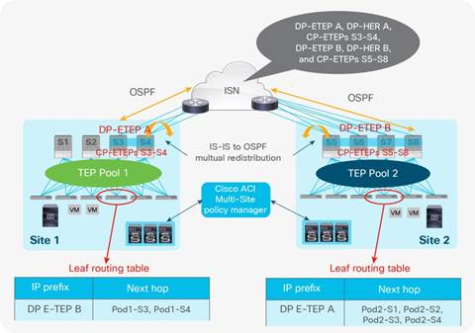

Several ETEP addresses are used for

* CP-ETEP : Control-Plane External Tunnel Endpoint (1 IP per spine)
* DP-ETEP : Data-Plane External Tunnel Endpoint (1 IP shared between all spines)
* HR-ETEP : Head-End Replication ETEP (1 IP shared between all spines)

Global ETEP Pool : ***1 x /21 needed 🡺 13.254.0.0/16 allocated***

/24 unique IP range for each multisite fabric   
🡺 subnetted into /28 IP range per site

|  |  |
| --- | --- |
| Node | IP address |
| Spine 1 CP-ETEP | 13.254.X.1 |
| Spine 2 CP-ETEP | 13.254.X.2 |
| Spine 2 CP-ETEP | 13.254.X.3 |
| DP-ETEP | 13.254.X.11 |
| HR-ETEP | 13.254.X.12 |

IP assignment rule : 13.254.X.0/28 (X = <Multi Site ID> x 10 + <Site ID>)

|  |  |  |  |  |  |  |
| --- | --- | --- | --- | --- | --- | --- |
| Fabric Code | DC2 | DB2 | DC5 | PAN | SC2 | DCX |
| ASU | 13.254.11.0/28 | 13.254.12.0/28 | 13.254.13.0/28 | 13.254.14.0/28 | 13.254.15.0/28 | 13.254.16.0/28 |
| RET | 13.254.21.0/28 | 13.254.22.0/28 | 13.254.23.0/28 | 13.254.24.0/28 | 13.254.25.0/28 | 13.254.26.0/28 |
| ALD | 13.254.41.0/28 | 13.254.42.0/28 | 13.254.43.0/28 | 13.254.44.0/28 | 13.254.45.0/28 | 13.254.46.0/28 |
| MKT | 13.254.51.0/28 | 13.254.52.0/28 | 13.254.53.0/28 | 13.254.54.0/28 | 13.254.55.0/28 | 13.254.56.0/28 |
| PLT | 13.254.61.0/28 | 13.254.62.0/28 | 13.254.63.0/28 | 13.254.64.0/28 | 13.254.65.0/28 | 13.254.66.0/28 |

## BD GIPO IP addresses

Inside a Pod (or ACI fabric), BUM traffic is encapsulated into a VXLAN multicast frame and it is always transmitted to all the local leaf nodes. A unique multicast group is associated to each defined Bridge Domain and takes the name of Bridge Domain ***Group IP–outer*** (BD GIPo).

Once received by the leafs, it is then forwarded to the connected devices that are part of that Bridge Domain or dropped depending on the type of BUM frame and on the specific Bridge Domain configuration.

A /15 must be used. Allowed IP range is 225.0.0.0/15 – 231.254.0.0/15.

[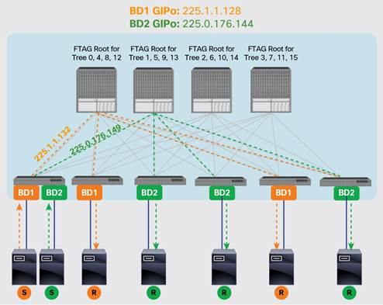](https://www.cisco.com/c/dam/en/us/solutions/collateral/data-center-virtualization/application-centric-infrastructure/white-paper-c11-737855.docx/_jcr_content/renditions/white-paper-c11-737855_9.jpg)

In SG Infrastructure the default IP range for BD GIPO will be used on every POD of all fabrics :

|  |  |  |
| --- | --- | --- |
| Fabric Code | Datacenter POD | GIPO Addresses |
| All | All | 225.0.0.0/15 |

## Tunnel end points (TEP)

Global TEP Pool : /16 IP range per fabric

IP assignment rule :

13.X.0.0/16 (X = <Multi Site ID> x 10 + <Site ID>)

Example :

MKT DC5 🡺 MKT Multi Site ID = 5 ; DC5 Site ID = 3 🡺 13.53.0.0/16

|  |  |  |  |  |  |  |
| --- | --- | --- | --- | --- | --- | --- |
| Fabric Code | DC2 | DB2 | DC5 | PAN | SC2 | DCX |
| ASU | 13.11.0.0/16 | 13.12.0.0/16 | 13.13.0.0/16 | 13.14.0.0/16 | 13.15.0.0/16 | 13.16.0.0/16 |
| RET | 13.21.0.0/16 | 13.22.0.0/16 | 13.23.0.0/16 | 13.24.0.0/16 | 13.25.0.0/16 | 13.26.0.0/16 |
| ALD | 13.41.0.0/16 | 13.42.0.0/16 | 13.43.0.0/16 | 13.44.0.0/16 | 13.45.0.0/16 | 13.46.0.0/16 |
| MKT | 13.51.0.0/16 | 13.52.0.0/16 | 13.53.0.0/16 | 13.54.0.0/16 | 13.55.0.0/16 | 13.56.0.0/16 |
| PLT | 13.61.0.0/16 | 13.62.0.0/16 | 13.63.0.0/16 | 13.64.0.0/16 | 13.65.0.0/16 | 13.66.0.0/16 |

IP addresses are automatically allocated by ACI. No need to define an IP allocation rule.

## Out of Band

Following global IP ranges have been booked for ACI OOB:

|  |  |
| --- | --- |
| Site | IP range |
| DC2 | 196.18.128.0/21 |
| DB2 | 196.66.128.0/21 |
| DC5 | 196.50.128.0/21 |
| PAN | 196.82.128.0/21 |
| SC2 | 196.34.128.0/21 |
| DCX | TBD |

OOB Pool : /24 IP range per site and per platform (max 250 nodes per POD is envisaged).

|  |  |  |  |  |  |  |
| --- | --- | --- | --- | --- | --- | --- |
| Fabric Code | DC2 | DB2 | DC5 | PAN | SC2 | DCX |
| ASU | 196.18.128.0/24 | 196.66.128.0/24 | None | None | None | None |
| RET | 196.18.129.0/24 | 196.66.129.0/24 | 196.50.129.0/24 | None | 196.34.128.0/24 | None |
| ALD | None | None | 196.50.128.0/24 | 196.82.128.0/24 | None | None |
| MKT | None | None | None | 196.82.129.0/24 | None | TBD |
| PLT | None | None | 196.50.130.0/24 | 196.82.130.0/24 | 196.34.130.0/24 | None |

Generic OOB IP allocation rules :

GW : X.X.X.254/24

Leaf Nodes : X.X.X.<Node-ID>/24 (Max 220)

N7K (VDC OTV Msite or Routing Msite) : X.X.X.[229 – 230]

Spine Nodes : X.X.X.[231 – 236]

N7K (Global context - admin) : X.X.X.[237 – 238]

N7K (VDC OTV Local) : X.X.X.[239 – 240]

APIC : X.X.X.[241 – 250]

MSC : X.X.X.[251 – 253]

## External Devices

Global External Devices IP address range : ***195.2.0.0/18***

* /21 unique IP range for each multisite fabric  
  🡺 subnetted into /24 IP range per site  
   🡺 subnetted into /29 for each Firewall or /30 for point to point (32 x interco /29 subnets)

|  |  |  |  |  |  |  |  |
| --- | --- | --- | --- | --- | --- | --- | --- |
| Fabric Code | Fabric IP range | DC2 | DB2 | DC5 | DCX | PAN | SC2 |
| ASU | 195.2.0.0/21 | 195.2.0.0/24 | 195.2.1.0/24 | None | None | None | None |
| RET | 195.2.8.0/21 | 195.2.8.0/24 | 195.2.9.0/24 | 195.2.10.0/24 | None | None | 195.2.11.0/24 |
| ALD | 195.2.24.0/21 | None | None | 195.2.24.0/24 | None | 195.2.25.0/24 | None |
| MKT | 195.2.32.0/21 | None | None | None | 195.2.32.0/24 | 195.2.33.0/24 | None |
| PLT | 195.2.40.0/21 | None | None | 195.2.40.0/24 | None | 195.2.41.0/24 | 195.2.42.0/24 |

For each 195.2.**X**.0/24 allocated to a given site and fabric we can allocate up to 51 x L3Out interconnexion with an ACI fabric:

* 195.2.X.1 to 51: will be used for IP Loopbacks (51 x /32)
* 195.2.X. to 255: /30 subnets (51 /30 subnets)

For each /30 subnet used for Point-to-Point interconnexion with an external device :

* **First IP address (odd value)** of interconnection subnet will be configured on external device (X.X.X.1)
* **Second IP address (even value)** of interconnection subnet will be configured on border/service leaf side (X.X.X.2)

## Router ID IP address

Loopback (Router ID) IP address range : ***195.2.0.0/18***

* /21 unique IP range for each multisite fabric  
  🡺 subnetted into /24 IP range per site (max 250 nodes per POD is envisaged).

|  |  |  |  |  |  |  |  |
| --- | --- | --- | --- | --- | --- | --- | --- |
| Fabric Code | Fabric IP range | DC2 | DB2 | DC5 | DCX | PAN | SC2 |
| ASU | 195.2.64.0/21 | 195.2.64.0/24 | 195.2.65.0/24 | None | None | None | None |
| RET | 195.2.72.0/21 | 195.2.72.0/24 | 195.2.73.0/24 | 195.2.74.0/24 | None | None | 195.2.75.0/24 |
| ALD | 195.2.88.0/21 | None | None | 195.2.88.0/24 | None | 195.2.89.0/24 | None |
| MKT | 195.2.96.0/21 | None | None | None | 195.2.96.0/24 | 195.2.97.0/24 | None |
| PLT | 195.2.104.0/21 | None | None | 195.2.104.0/24 | None | 195.2.105.0/24 | 195.2.106.0/24 |

For each 195.2.**X**.0/24 allocated to a given site and fabric we can allocate up to 256 Router ID.

## Customer IP addressing and migration strategy

In order to limit migration impacts, a specific OTV network will be built for migration purpose.

Customer IP addresses can’t be kept if :

* Migrated platform is moving from physical to cloud
* Migrated platform is mutualized with another one (example VIP ranges) and is migrated on several sites

SGNA is the target addressing plan for any application hosted in SG Datacenters.

If an application has to be readdressed, it will be the opportunity to **move to SGNA and to remove NAT** (when it is currently used).

# Service description

## Tenants

Tenant Alias will be used to get human readable tenant identifier.

Tenant Name will be a generic identifier :   
TN<ID>

* **<ID>** : a 3 digit value (with heading 0)

|  |  |  |
| --- | --- | --- |
| Fabric Code | Tenant Alias | Tenant Name |
| ASU | ASSU | TN001 |
| RET | BDDF  CDN  BSC | TN001  TN002  TN003 |
| ALD | ALD | TN001 |
| MKT | SGCIB  SGSS  CGA | TN001  TN002  TN003 |
| PLT | CLOUD  WORKPLACE  SHARED  BIGDATA | TN001  TN002  TN003  TN004 |

Later on, if more specific tenants are needed, they could be added.

Tenant location :

|  |  |  |
| --- | --- | --- |
| Tenant Alias | Fabric | Sites |
| ASSU | ASSU | DC2, DB2 |
| BDDF | RETAIL | DC2, DC5, DB2, SC2 |
| CDN | RETAIL | DC2, DC5, DB2, SC2 |
| BSC | RETAIL | DC2, DC5, DB2, SC2 |
| ALD | ALD | DC5, PAN |
| SGCIB | MARKET | DCX, PAN |
| SGSS | MARKET | DCX, PAN |
| CGA | MARKET | DCX, PAN |
| CLOUD | PLATFORM | DC5, PAN, SC2 |
| WORKPLACE | PLATFORM | DC5, SC2 |
| SHARED | PLATFORM | DC5, PAN, SC2 |
| BIGDATA | PLATFORM | DC5, SC2 |

## VRF (Private Networks)

VRF Name : <MAN VRF NAME>_VRF

## Bridge Domain (BD)

VLAN_<VLAN ID>[_<INFRA_CODE>]_BD

<VLAN ID> : Vlan Identifier [1 .. 3966]

<INFRA_CODE> : Infrastructure code to be used when a same VLAN is used on several platforms.  
**/!\** : it is not possible to use a same VLAN ID on several EPGs on a single leaf.

## EPG

VLAN_<VLAN ID>[_<INFRA_CODE>]_EPG

<VLAN ID> : Vlan Identifier [1 .. 3966]

<INFRA_CODE> : Infrastructure code to be used when a same VLAN is used on several platform.

**/!\** : it is not possible to use a same VLAN ID on several EPGs on a single leaf.

## L3Out (External Routed Network)

Following data model is used for L3Out (External Routed Network) definition:



VRF Name : <MAN VRF NAME>_VRF

External Routed Networks/L3Out : L3OUT_<MAN VRF NAME>_VRF_MAN

Logical Node Profile Name :

BRD_<Node-ID1>_<Node-ID2> (both border leaves of the considered fabric)

BRD_101_201 : for fabric initial setup

SRV_<Node-ID1>_<Node-ID2> (both service leaves of the considered fabric)

SRV_102_202 : for fabric initial setup

Logical Node Interface profile:

SUB_INT_<Node-ID>_<MAN VRF NAME>_VRF_MAN : for MAN VRF interco on border leaves

SUB_INT_<Node-ID>_<Service Node > : for other nodes interco on service leaves

Networks/External EPG:

External EPG associate to subnet ( FLAG = External Subnets for the external EPG )

EXT_EPG_<VRF>_<SVC>

<SVC>: {MAN / VIP_LB /*to be completed* }

Map Route to advertise or Receive associate to a specific service:

NET_ADV_<VRF>_<SVC-FROM>_<SVC-TO>

NET_RCV_<VRF>_<SVC-FROM>

<SVC-FROM> / <SVC-TO>: {VIP_LB / DMZ_FW / TO_MAN / *to be completed*}

# Fabric description

## Attachment datamodel overview



## Generic naming convention

Following naming convention will be used :



Network node interface policies will be bound to PDOM_COMMON or L3DOM_COMMON through a specific AEP.

Compute node interface policies will be bound to a specific PDOM_<Tenant> which is bound to the logical entity security domain. This is allowing to have a specific compute port configuration policy for each entity.



### VLAN Pools

VLANP_ALL : will be widely used to allow binding onto [1 .. 3966] VLAN range.

### Domains

Several domains will be defined into ACI. They are :

* Physical Domains (for user nodes attachment) : PDOM_<Tenant>
* External Bridged Domains (for L2 interconnexion) : L2DOM_<Tenant>  
   ***(currently unused)***
* External Routed Domains (for L3 interconnexion) : L3DOM_<Tenant>



### AAEP (Attachable Access Entity Profiles)

Several AAEP will be defined into ACI. They are :

* AEP_<Tenant>_COMPUTE : for server connectivity
* AEP_<Tenant>_L2NET : for directly connected network node interconnexion ***(no IP routing)***

🡺 used for Network devices connected onto border or service leaves (COMMON tenant)

* AEP_<Tenant>_L3NET : for routed network node interconnexion  
  🡺 used for Network devices connected onto border or service leaves (COMMON tenant)



### Interface Policy Group

#### Server node – standard setup

Servers are connected on entity Leaf switches.

Three kinds of interfaces policy group will be defined for computes :

* INTPOL_<Tenant>_COMPUTE : single port or dual independent ports for any COMPUTE node
* INTPOL_<Tenant>_<description>_PC : port channel for a given compute node
* INTPOL_<Tenant>_<description>_VPC : virtual port channel for a given compute node

With :

* <Tenant> : cf per fabric logical entities



PS: Compute AEP won’t be created for COMMON tenant as no compute are foreseen on service and border leaves.

PS2 : When required, if a specific port speed has to be forced on some given ports a more specific policy could be created

* INTPOL_<Tenant>_<Speed>_COMPUTE : single port or dual independent ports for any COMPUTE node
* INTPOL_<Tenant>_<Speed>_<description>_PC : port channel for a given compute node
* INTPOL_<Tenant>_<Speed>_<description>_VPC : virtual port channel for a given compute node

With :

* <Tenant> : cf per fabric logical entities
* <Speed> : interface speed (100M, 1G, 10G, 25G, 40G, 50G, 100G)

**Pre-provisioned VPC 2 or 4 Links**

Every server connected to the fabric must be dual-attached on two distinct ports with LACP enabled.

A VPC for every single port will be pre-configured on each end-user Leaf switch pair :

INTPOL_<Tenant>_<description>_VPC 🡸 For Border Leaf

INTPOL_<Tenant>_<description>_VPC2 🡸 For End User Leaf and service leaf

INTPOL_<Tenant>_<description>_VPC4 🡸 For End User Leaf and service leaf

With :

* <Tenant> : cf per fabric logical entities
* <description> : LEF_<ID1>_<ID2>_INT_S_P  
  with :
  + <ID> : 3 digit leaf ID (with heading 0).
  + S_P : single port S/P

INTPOL_<Tenant>_<description>_VPC4 🡸 For End User Leaf and service leaf

With :

* <Tenant> : cf per fabric logical entities
* <description> : LEF_<ID1>_<ID2>_INT_S_P_S_P  
  with :
  + <ID> : 3 digit leaf ID (with heading 0).
  + S_P : single port S/P

**For Border Leaf**

|  |  |
| --- | --- |
| Interface Policy Group | AAEP |
| INTPOL_<Tenant>_LEF_103_203_INT_1_1_VPC | AEP_<Tenant>_COMPUTE |
| INTPOL_<Tenant>_LEF_103_203_INT_1_2_VPC | AEP_<Tenant>_COMPUTE |
| … |  |
| INTPOL_<Tenant>_LEF_103_203_INT_1_48_VPC | AEP_<Tenant>_COMPUTE |
| INTPOL_<Tenant>_LEF_104_204_INT_1_1_VPC | AEP_<Tenant>_COMPUTE |
| INTPOL_<Tenant>_LEF_104_204_INT_1_2_VPC | AEP_<Tenant>_COMPUTE |
| … |  |
| INTPOL_<Tenant>_LEF_104_204_INT_1_48_VPC | AEP_<Tenant>_COMPUTE |
| … |  |
| INTPOL_<Tenant>_LEF_1NN_2NN_INT_1_1_VPC | AEP_<Tenant>_COMPUTE |
| INTPOL_<Tenant>_LEF_1NN_2NN_INT_1_2_VPC | AEP_<Tenant>_COMPUTE |
| … |  |
| INTPOL_<Tenant>_LEF_1NN_2NN_INT_1_48_VPC | AEP_<Tenant>_COMPUTE |

**For End User Leaf and Service Leaf with 2 Links**

|  |  |
| --- | --- |
| Interface Policy Group | AAEP |
| INTPOL_<Tenant>_LEF_103_203_INT_1_1_VPC2 | AEP_<Tenant>_COMPUTE |
| INTPOL_<Tenant>_LEF_103_203_INT_1_2_VPC2 | AEP_<Tenant>_COMPUTE |
| … |  |
| INTPOL_<Tenant>_LEF_103_203_INT_1_48_VPC2 | AEP_<Tenant>_COMPUTE |
| INTPOL_<Tenant>_LEF_104_204_INT_1_1_VPC2 | AEP_<Tenant>_COMPUTE |
| INTPOL_<Tenant>_LEF_104_204_INT_1_2_VPC2 | AEP_<Tenant>_COMPUTE |
| … |  |
| INTPOL_<Tenant>_LEF_104_204_INT_1_48_VPC2 | AEP_<Tenant>_COMPUTE |
| … |  |
| INTPOL_<Tenant>_LEF_1NN_2NN_INT_1_1_VPC2 | AEP_<Tenant>_COMPUTE |
| INTPOL_<Tenant>_LEF_1NN_2NN_INT_1_2_VPC2 | AEP_<Tenant>_COMPUTE |
| … |  |
| INTPOL_<Tenant>_LEF_1NN_2NN_INT_1_48_VPC2 | AEP_<Tenant>_COMPUTE |

**For End User Leaf and Service Leaf with 4 Links**

|  |  |
| --- | --- |
| Interface Policy Group | AAEP |
| INTPOL_<Tenant>_LEF_103_203_INT_1_1_2_VPC4 | AEP_<Tenant>_COMPUTE |
| INTPOL_<Tenant>_LEF_103_203_INT_1_3_4_VPC2 | AEP_<Tenant>_COMPUTE |
| … |  |
| INTPOL_<Tenant>_LEF_103_203_INT_1_47_48_VPC4 | AEP_<Tenant>_COMPUTE |
| INTPOL_<Tenant>_LEF_104_204_INT_1_1_2_VPC4 | AEP_<Tenant>_COMPUTE |
| INTPOL_<Tenant>_LEF_104_204_INT_1_3_4_VPC4 | AEP_<Tenant>_COMPUTE |
| … |  |
| INTPOL_<Tenant>_LEF_104_204_INT_1_47_48_VPC4 | AEP_<Tenant>_COMPUTE |
| … |  |
| INTPOL_<Tenant>_LEF_1NN_2NN_INT_1_1_2_VPC4 | AEP_<Tenant>_COMPUTE |
| INTPOL_<Tenant>_LEF_1NN_2NN_INT_1_3_4_VPC4 | AEP_<Tenant>_COMPUTE |
| … |  |
| INTPOL_<Tenant>_LEF_1NN_2NN_INT_1_47_48_VPC4 | AEP_<Tenant>_COMPUTE |

#### Server node – specific setup

When a server is requiring a specific setup which is not the standard VPC configuration :

* Individual ports with a specific policy
  + Blade interco
  + Dual ports Active/Backup
  + Dual ports Active/Active with MAC pinning
* Port channels

We will have to create specific interface policy groups.



/!\: Before to integrate a port into a new policy group, preconfigured VPC (INTPOL_<Tenant>_LEF_1NN_2NN_INT_1_1_VPC) policy has to be removed first.

**Specific PC or VPC**

For each PC or VPC to be configured a specific Access Leaf Policy group have to be created for each link group :

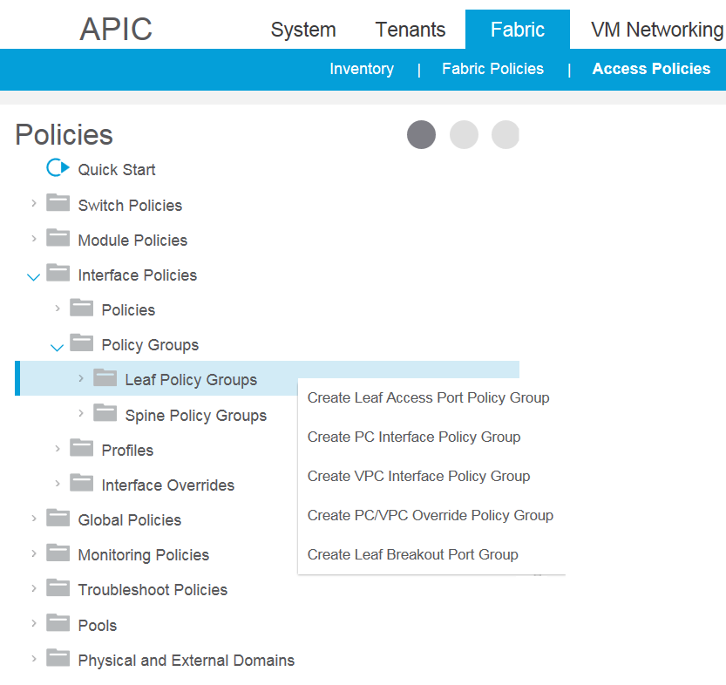

#### Specific configurations and interface configuration policies impacts

At fabric startup, all production ports are preconfigured by pair in VPC.

For any specific other use case (PC, dual independent ports resiliency) specific configuration profiles will have to be added and the pre-configuration profile will have to be removed.

**/!\ Per-Port VLAN usage is not foreseen into SG ACI fabric due to the heavy impact it would have.**

Indeed, in order to manage VLAN overlap a new specific physical domain would have to be created in order to keep separated the “overlapping” infrastructure from the “main” one.



#### Directly connected network node (no IP routing)

Network nodes are connected on Service (or Border) Leaf switches. They will be managed under “Common” tenant.

Three kinds of interfaces policy group will be defined for directly connected network function node :

* INTPOL_<Tenant>_L2NET : single port or dual independent ports for any directly connected network node (Firewall, Service Load Balancer, …)
* INTPOL_<Tenant>_<description>_PC : port channel for a given directly connected network node (Firewall, Service Load Balancer, …)
* INTPOL_<Tenant>_<description>_VPC : virtual port channel for a given directly connected network node (Firewall, Service Load Balancer, …)

With :

* <Tenant> : cf per fabric logical entity (COMMON for every network node)



PS: L2NET AEP will only be created onto COMMON tenant as Service and Border leaves are shared between all entities and not delegated.

PS : When required, if a specific port speed has to be forced on some given ports a more specific policy could be created

* INTPOL_<Tenant>_<Speed>_L2NET : single port or dual independent ports for any routed network node (Firewall, Service Load Balancer, …)
* INTPOL_<Tenant>_<Speed>_<description>_PC : port channel for a given routed network node (Firewall, Service Load Balancer, …)
* INTPOL_<Tenant>_<Speed>_<description>_VPC : virtual port channel for a given routed network node (Firewall, Service Load Balancer, …)

With :

* <Tenant> : cf per fabric logical entities (COMMON for every network node)
* <Speed> : interface speed (100M, 1G, 10G, 25G, 40G, 50G, 100G)

#### Routed network node

Network nodes are connected on Service (or Border) Leaf switches. They will be managed under “COMMON” tenant.

Three kinds of interfaces policy group will be defined for routed network function node :

* INTPOL_<Tenant>_L3NET : single port or dual independent ports for any routed network node (Firewall, Service Load Balancer, …)
* INTPOL_<Tenant>_<description>_PC : port channel for a given routed network node (Firewall, Service Load Balancer, …)
* INTPOL_<Tenant>_<description>_VPC : virtual port channel for a given routed network node (Firewall, Service Load Balancer, …)

With :

* <Tenant> : cf per fabric logical entities (COMMON for every network node)



PS: L3NET AEP will only be created onto COMMON tenant as Service and Border leaves are shared between all entities and not delegated.

PS : When required, if a specific port speed has to be forced on some given ports a more specific policy could be created

* INTPOL_<Tenant>_<Speed>_L3NET : single port or dual independent ports for any routed network node (Firewall, Service Load Balancer, …)
* INTPOL_<Tenant>_<Speed>_<description>_PC : port channel for a given routed network node (Firewall, Service Load Balancer, …)
* INTPOL_<Tenant>_<Speed>_<description>_VPC : virtual port channel for a given routed network node (Firewall, Service Load Balancer, …)

With :

* <Tenant> : cf per fabric logical entities (COMMON for every network node)
* <Speed> : interface speed (100M, 1G, 10G, 25G, 40G, 50G, 100G)

/!\ : Target situation for Border leaf is common tenant. All Border leaf ports will have to be gathered into AEP_COMMON_L3NET.

/!\ : Currently sharing objects in common tenants is not supported for the moment. It means each tenant will have to create a specific L3Out using AEP_COMMON_L3NET ports.

#### Interface policies

Interface policies are required into interface policy groups in order to manage link level configuration. Following interface policies will be preconfigured into ACI fabrics in order to be reused into previously described interface policy groups :



Default setup for dual attached Compute ports in a VPC will be :

* Link Level Policy : **AUTO_ON**
* CDP Policy : **CDP_ON**
* MCP Policy : **MCP_ON**
* LLDP Policy : **LLDP_ON**
* Port Channel Policy : **LACP_ACTIVE**

Default setup for Single or Dual-Independent Compute ports will be :

* Link Level Policy : **AUTO_ON**
* CDP Policy : **CDP_ON**
* MCP Policy : **MCP_ON**
* LLDP Policy : **LLDP_ON**
* Port Channel Policy : **LACP_OFF**

**LACP_ACTIVE**

Following setup will be configured in LACP_ACTIVE profile :

* **Fast Select Hot Standby Ports**: Configures fast select for hot standby ports. Enabling this feature will allow fast selection of a hot standby port when last active port in the port-channel is going down.
* **Graceful Convergence**: Configures port-channel LACP graceful convergence. Disable this only with LACP ports connected to a Non-Nexus peer. Disabling this with Nexus peer can lead to port suspension.
* **Suspend Individual Ports**: LACP sets a port to the suspended state if it does not receive an LACP bridge protocol data unit (BPDU) from the peer ports in a port channel. This can cause some servers to fail to boot up as they require LACP to logically bring up the port.

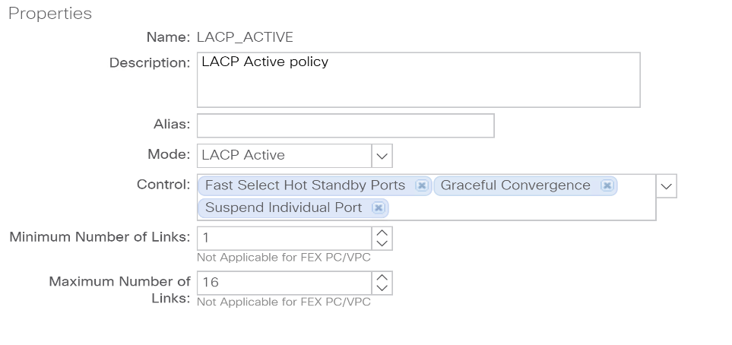

**Important Notice** :

Servers that need PXE boot aren't using LACP during the boot time. So ACI will suspend the ports and server will not be able to reach PXE server. Server auto-configuration process will fail.

Servers that require PXE boot need to have Individual suspend disabled on access switch port they are connected to. Another solution would be to change the access switch port configuration during the autoconfiguration process and to configure LACP only after the server autoconfiguration is completed.

### Interface Profile

Two kinds of interface profiles will be defined :

* INTPRO_BRD_<Switch ID **1**>_<Switch ID **2**> : to select a list of ports on a switch pair
* INTPRO_BRD_<Switch ID> : to select a list of ports on single switch
* INTPRO_LEF_<Switch ID **1**>_<Switch ID **2**> : to select a list of ports on a switch pair
* INTPRO_LEF_<Switch ID> : to select a list of ports on single switch

With :

* <Switch ID> : Leaf switch identifier

### Interface Selector

**For Border LEAF**

INT_<range>

With :

* <range > : range of selected ports
  + S_P : single port S/P
  + S_X_to_S_Y : set of ports S/X to S/Y

Example :



**For End User Leaf and Service Leaf**

INT_<range>_SWICTHPORT

INT_<range>_PC

INT_<range>_VPC<NB_PORT>

* <NB_PORT> : could be 2 for 2 links 1 per switch or 4 links 2 per switch

With :

* <range > : range of selected ports
  + S_P : single port S/P
  + S_X_to_S_Y : set of ports S/X to S/Y

Example :

INT_1_5_to_1_9 : to select a set of ports on a same line card (1/5 to 1/9)

INT_1_4 : to select a given port (1/4)



### VPC domains

A VPC domain will have to be created for each LEAF switch pair.

We will use following naming convention :

VPC_DOM_<Domain ID>_<LEAF ID 1>_<LEAF ID 2>

With :

* Domain ID : 3 digit domain ID (with heading 0)
* LEAF ID 1 and LEAF ID 2 : 3 digit Leaf ID (with heading 0)

|  |  |  |  |
| --- | --- | --- | --- |
| VPC Domain Name | Domain ID | First Switch | Second Switch |
| VPC_DOM_001_101_201 | 1 | 10**1** | 20**1** |
| VPC_DOM_002_102_202 | 1 | 10**2** | 20**2** |
|  |  |  |  |
| VPC_DOM_0NN_1NN_2NN | 1 | 1**NN** | 2**NN** |

### Switch Profile

Switch profiles are split in two different types : Spine of Leaf

Leaf Switch profiles :

* SWPRO_LEF_<Switch ID **1**>_<Switch ID **2**> : to manage configuration of a switch pair
* SWPRO_LEF_<Switch ID> : to manage configuration of a single production switch

With :

* <Switch ID> : Leaf switch identifier



Spine Switch profile :

* SWPRO_SPN_1001_1002_1003 : to manage configuration of all spines



### Switch Selector

Following naming convention will be used for leaf switches :

LEF_<range>

With :

* <range > : range of selected ports
  + <Switch ID **1**>_<Switch ID **2**> : to select a switch pair
  + <Switch ID> : to select a single switch

Following naming convention will be used for spine switches :

* SPN_1001_1002_1003 : to select all spines

### Switch Policy Group

Switch policy group are split in two different types : Spine of Leaf

SWPOL_<description>

With :

* <description> : description of the switch profile configuration purpose

## ISN Attachment

### Network Interconnexion description

Each fabric spine two interconnexion links with SG MAN



Each interconnexion link is a routed point to point sub-interface on which OSPF is activated :



VLAN tag 4 is used to define the ISN sub-interface on all PE to SPINE ISN links.

### VLAN Pools

VLAN ID 4 must be used on ISN ports. Following VLAN name *VLANP_ISN_4* will be used on ISN interconnexion.

|  |  |
| --- | --- |
| Name | VLAN ID range |
| VLANP_ISN_4 | 4 |

### External Routed Domain

A single physical domain will be used for ISN interconnexion: *L3DOM_ISN*.

|  |  |
| --- | --- |
| Name | VLAN Pool |
| L3DOM_ISN | VLANP_ISN_4 |

### AAEP (Attachable Access Entity Profiles)

A single AAEP (Attachable Access Entity Profile) will be used for ISN interconnexion: *AEP_ISN*.

|  |  |
| --- | --- |
| Name | Physical Domain |
| AEP_ISN | L3DOM_ISN |

# OTV Network

## Overview

MAN network will be used to interconnect OTV nodes between themselves :



MTU setup used on OTV will be 8500 on MAN links.

Two OTV VRF will be built into the MAN (1 for each OTV VDC context) :

* RVP_ACI_LOCAL_OTV : for Local OTV instances (used to migrate not stretched BD)
* RVP_ACI_MSITE_OTV : for Multisite OTV instances (used to migrate stretched BD)

## OTV interconnexion with MAN network

Following IP range has been allocated for the build of OTV networks needed for migrations :

192.4.254.0/23

* Local OTV Central Sites : 192.4.254.0/25
* Local OTV Legacy Sites : 192.4.254.128/25
* Multisite OTV Central Sites : 192.4.255.0/25
* Multisite OTV Legacy Sites : 192.4.255.128/25

A /30 IP network will be allocated for each point to point interconnexion :

* **First IP address (odd value)** of interconnection subnet will be configured on MAN side (X.X.X.1)
* **Second IP address (even value)** of interconnection subnet will be configured on ACI side (X.X.X.2)

### Local OTV for not stretched BD

Local OTV Central Sites : 192.4.254.0/25

|  |  |  |  |  |  |  |  |
| --- | --- | --- | --- | --- | --- | --- | --- |
| OTV Pair | VDC Context | OTV Transport VRF | Routing Plane | | OTV Node | | Interco IP |
| ASU-DC2 | LOCAL_OTV | RVP_ACI_LOCAL_OTV | RED | | ASU-N7K-DC2-<Room Code>-2001 | | 192.4.254.0/30 |
| BLUE | | ASU-N7K-DC2-<Room Code>-2002 | | 192.4.254.4/30 |
| ASU-DB2 | LOCAL_OTV | RVP_ACI_LOCAL_OTV | RED | | ASU-N7K-DB2-<Room Code>-2001 | | 192.4.254.8/30 |
| BLUE | | ASU-N7K-DB2-<Room Code>-2002 | | 192.4.254.12/30 |
| PLT-DC5 | LOCAL_OTV | RVP_ACI_LOCAL_OTV | RED | | PLT-N7K-DC5-<Room Code>-2001 | | 192.4.254.16/30 |
| BLUE | | PLT-N7K-DC5-<Room Code>-2002 | | 192.4.254.20/30 |
| PLT-PAN | LOCAL_OTV | RVP_ACI_LOCAL_OTV | RED | | PLT-N7K-PAN-<Room Code>-2001 | | 192.4.254.24/30 |
| BLUE | | PLT-N7K-PAN-<Room Code>-2002 | | 192.4.254.28/30 |
| PLT-SC2 | LOCAL_OTV | RVP_ACI_LOCAL_OTV | RED | | PLT-N7K-SC2-<Room Code>-2001 | | 192.4.254.32/30 |
| BLUE | | PLT-N7K-SC2-<Room Code>-2002 | | 192.4.254.36/30 |
| MKT-DCX | LOCAL_OTV | RVP_ACI_LOCAL_OTV | RED | | MKT-N7K-DCX-<Room Code>-2001 | | 192.4.254.40/30 |
| BLUE | | MKT-N7K-DCX-<Room Code>-2002 | | 192.4.254.44/30 |
| MKT-PAN | LOCAL_OTV | RVP_ACI_LOCAL_OTV | RED | | MKT-N7K-PAN-<Room Code>-200**1** | | 192.4.254.48/30 |
| BLUE | | MKT-N7K-PAN-<Room Code>-200**2** | | 192.4.254.52/30 |
| RET-DC2 | LOCAL_OTV | RVP_ACI_LOCAL_OTV | RED | | RET-N7K-DC2-<Room Code>-200**1** | | 192.4.254.56/30 |
| BLUE | | RET-N7K-DC2-<Room Code>-200**2** | | 192.4.254.60/30 |
| RET-DB2 | LOCAL_OTV | RVP_ACI_LOCAL_OTV | RED | | RET-N7K-DB2-<Room Code>-200**1** | | 192.4.254.64/30 |
| BLUE | | RET-N7K-DB2-<Room Code>-200**2** | | 192.4.254.68/30 |
| RET-SC2 | LOCAL_OTV | RVP_ACI_LOCAL_OTV | | RED | | RET-N7K-SC2-<Room Code>-200**1** | 192.4.254.72/30 |
| BLUE | | RET-N7K-SC2-<Room Code>-200**2** | 192.4.254.76/30 |
| RET-DC5 | LOCAL_OTV | RVP_ACI_LOCAL_OTV | | RED | | RET-N7K-DC5-<Room Code>-200**1** | 192.4.254.80/30 |
| BLUE | | RET-N7K-DC5-<Room Code>-200**2** | 192.4.254.84/30 |
| ALD-DC5 | LOCAL_OTV | RVP_ACI_LOCAL_OTV | | RED | | ALD-N7K-DC5-<Room Code>-200**1** | 192.4.254.88/30 |
| BLUE | | ALD-N7K-DC5-<Room Code>-200**2** | 192.4.254.92/30 |
| ALD-PAN | LOCAL_OTV | RVP_ACI_LOCAL_OTV | | RED | | ALD-N7K-PAN-<Room Code>-200**1** | 192.4.254.96/30 |
| BLUE | | ALD-N7K-PAN-<Room Code>-200**2** | 192.4.254.100/30 |

Local OTV Legacy Sites : 192.4.254.128/25

|  |  |  |  |  |  |  |  |
| --- | --- | --- | --- | --- | --- | --- | --- |
| OTV Pair | VDC Context | OTV Transport VRF | Routing Plane | | OTV Node | | Interco IP |
| ASU-ORL-L | LOCAL_OTV | RVP_ACI_LOCAL_OTV | RED | | ASU-N7K-ORL-<Room Code>-200**3** | | 192.4.254.128/30 |
| BLUE | | ASU-N7K-ORL-<Room Code>-200**4** | | 192.4.254.132/30 |
| RET-TIG-L | LOCAL_OTV | RVP_ACI_LOCAL_OTV | RED | | RET-N7K-TIG-<Room Code>-200**3** | | 192.4.254.136/30 |
| BLUE | | RET-N7K-TIG-<Room Code>-200**4** | | 192.4.254.140/30 |
| MKT-TIG-L | LOCAL_OTV | RVP_ACI_LOCAL_OTV | RED | | MKT-N7K-TIG-<Room Code>-200**3** | | 192.4.254.144/30 |
| BLUE | | MKT-N7K-TIG-<Room Code>-200**4** | | 192.4.254.148/30 |
| PLT-TIG-L | LOCAL_OTV | RVP_ACI_LOCAL_OTV | RED | | PLT-N7K-TIG-<Room Code>-200**3** | | 192.4.254.152/30 |
| BLUE | | PLT-N7K-TIG-<Room Code>-200**4** | | 192.4.254.156/30 |
| MKT-CLI-L | LOCAL_OTV | RVP_ACI_LOCAL_OTV | RED | | MKT-N7K-CLI-<Room Code>-200**3** | | 192.4.254.160/30 |
| BLUE | | MKT-N7K-CLI-<Room Code>-200**4** | | 192.4.254.164/30 |
| RET-SC2-L | LOCAL_OTV | RVP_ACI_LOCAL_OTV | RED | | RET-N7K-SC2-<Room Code>-200**3** | | 192.4.254.168/30 |
| BLUE | | RET-N7K-SC2-<Room Code>-200**4** | | 192.4.254.172/30 |
| PLT-SC2-L | LOCAL_OTV | RVP_ACI_LOCAL_OTV | RED | | PLT-N7K-SC2-<Room Code>-200**3** | | 192.4.254.176/30 |
| BLUE | | PLT-N7K-SC2-<Room Code>-200**4** | | 192.4.254.180/30 |
| RET-DC2-L | LOCAL_OTV | RVP_ACI_LOCAL_OTV | RED | | RET-N7K-DC2-<Room Code>-200**3** | | 192.4.254.184/30 |
| BLUE | | RET-N7K-DC2-<Room Code>-200**4** | | 192.4.254.188/30 |
| ASU-DC2-L | LOCAL_OTV | RVP_ACI_LOCAL_OTV | RED | | ASU-N7K-DC2-<Room Code>-200**3** | | 192.4.254.192/30 |
| BLUE | | ASU-N7K-DC2-<Room Code>-200**4** | | 192.4.254.196/30 |
| PLT-DC2-L | LOCAL_OTV | RVP_ACI_LOCAL_OTV | RED | | PLT-N7K-DC2-<Room Code>-200**3** | | 192.4.254.200/30 |
| BLUE | | PLT-N7K-DC2-<Room Code>-200**4** | | 192.4.254.204/30 |
| PLT-CLI-L | LOCAL_OTV | RVP_ACI_LOCAL_OTV | | RED | | PLT-N7K-CLI-<Room Code>-200**3** | 192.4.254.208/30 |
| BLUE | | PLT-N7K-CLI-<Room Code>-200**4** | 192.4.254.212/30 |

### Multisite OTV for stretched BD

Multisite OTV Central Sites : 192.4.255.0/25

|  |  |  |  |  |  |
| --- | --- | --- | --- | --- | --- |
| OTV Pair | VDC Context | OTV Transport VRF | Routing Plane | OTV Node | Interco IP |
| ASU-DC2-DB2 | MSITE_OTV | RVP_ACI_MSITE_OTV | RED | ASU-N7K-DC2-<Room Code>-200**1** | 192.4.255.0/30 |
| BLUE | ASU-N7K-DB2-<Room Code>-200**2** | 192.4.255.4/30 |
| PLT-DC5-PAN | MSITE_OTV | RVP_ACI_MSITE_OTV | RED | PLT-N7K-DC5-<Room Code>-200**1** | 192.4.255.8/30 |
| BLUE | PLT-N7K-PAN-<Room Code>-200**2** | 192.4.255.12/30 |
| MKT-DCX-PAN | MSITE_OTV | RVP_ACI_MSITE_OTV | RED | MKT-N7K-DCX-<Room Code>-200**1** | 192.4.255.16/30 |
| BLUE | MKT-N7K-PAN-<Room Code>-200**2** | 192.4.255.20/30 |
| RET-DC5-DB2 | MSITE_OTV | RVP_ACI_MSITE_OTV | RED | RET-N7K-DC5-<Room Code>-200**1** | 192.4.255.24/30 |
| BLUE | RET-N7K-DB2-<Room Code>-200**2** | 192.4.255.28/30 |
| ALD-DC5-PAN | MSITE_OTV | RVP_ACI_MSITE_OTV | RED | ALD-N7K-DC5-<Room Code>-200**1** | 192.4.255.32/30 |
| BLUE | ALD-N7K-PAN-<Room Code>-200**2** | 192.4.255.36/30 |

Multisite OTV Legacy Sites : 192.4.255.128/25

|  |  |  |  |  |  |
| --- | --- | --- | --- | --- | --- |
| OTV Pair | VDC Context | OTV Transport VRF | Routing Plane | OTV Node | Interco IP |
| ASU-ORL-M | MSITE_OTV | RVP_ACI_MSITE_OTV | RED | ASU-N7K-ORL-<Room Code>-200**3** | 192.4.255.128/30 |
| BLUE | ASU-N7K-ORL-<Room Code>-200**4** | 192.4.255.132/30 |
| RET-TIG-M | MSITE_OTV | RVP_ACI_MSITE_OTV | RED | RET-N7K-TIG-<Room Code>-200**3** | 192.4.255.136/30 |
| BLUE | RET-N7K-TIG-<Room Code>-200**4** | 192.4.255.140/30 |
| MKT-TIG-M | MSITE_OTV | RVP_ACI_MSITE_OTV | RED | MKT-N7K-TIG-<Room Code>-200**3** | 192.4.255.144/30 |
| BLUE | MKT-N7K-TIG-<Room Code>-200**4** | 192.4.255.148/30 |
| PLT-TIG-M | MSITE_OTV | RVP_ACI_MSITE_OTV | RED | PLT-N7K-TIG-<Room Code>-200**3** | 192.4.255.152/30 |
| BLUE | PLT-N7K-TIG-<Room Code>-200**4** | 192.4.255.156/30 |
| MKT-CLI-M | MSITE_OTV | RVP_ACI_MSITE_OTV | RED | MKT-N7K-CLI-<Room Code>-200**3** | 192.4.255.160/30 |
| BLUE | MKT-N7K-CLI-<Room Code>-200**4** | 192.4.255.164/30 |
| RET-SC2-M | MSITE_OTV | RVP_ACI_MSITE_OTV | RED | RET-N7K-SC2-<Room Code>-200**3** | 192.4.255.168/30 |
| BLUE | RET-N7K-SC2-<Room Code>-200**4** | 192.4.255.172/30 |
| PLT-SC2-M | MSITE_OTV | RVP_ACI_MSITE_OTV | RED | PLT-N7K-SC2-<Room Code>-200**3** | 192.4.255.176/30 |
| BLUE | PLT-N7K-SC2-<Room Code>-200**4** | 192.4.255.180/30 |
| RET-DC2-M | MSITE_OTV | RVP_ACI_MSITE_OTV | RED | RET-N7K-DC2-<Room Code>-200**3** | 192.4.255.184/30 |
| BLUE | RET-N7K-DC2-<Room Code>-200**4** | 192.4.255.188/30 |
| ASU-DC2-M | MSITE_OTV | RVP_ACI_MSITE_OTV | RED | ASU-N7K-DC2-<Room Code>-200**3** | 192.4.255.192/30 |
| BLUE | ASU-N7K-DC2-<Room Code>-200**4** | 192.4.255.196/30 |
| PLT-DC2-M | MSITE_OTV | RVP_ACI_MSITE_OTV | RED | PLT-N7K-DC2-<Room Code>-200**3** | 192.4.255.200/30 |
| BLUE | PLT-N7K-DC2-<Room Code>-200**4** | 192.4.255.204/30 |
| PLT-CLI-M | MSITE_OTV | RVP_ACI_MSITE_OTV | RED | PLT-N7K-CLI-<Room Code>-200**3** | 192.4.255.208/30 |
| BLUE | PLT-N7K-CLI-<Room Code>-200**4** | 192.4.255.212/30 |

# Multisite Site Controller

## Model Overview

Multisite controllers are using schemas and templates in order to manage globally configuration of a multisite fabric.

A schema is made up of a maximum of 5 Templates.

A template is applied to a given list of fabric pod. A maximum of 200 templates can be defined onto a MSC.

We will deploy on each MSC several schemas (1 per VRF) in which we will configure up to 5 templates (maximum of 40 schema with 5 templates = VRF could be managed – 40 x 5 = 200 templates) :

* A DC_ALL template in order to apply a configuration on all sites of a given multi sites fabric
* Several DC_<Site Name> templates : in order to apply a configuration on only one given site of the multisite fabric (*a multisite fabric with a maximum of 4 sites can be managed* with such strategy).

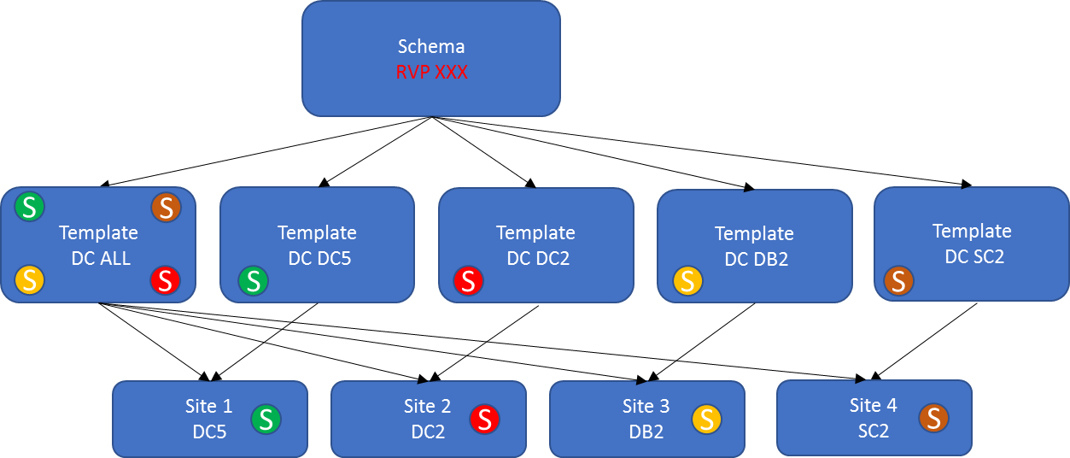

Last scalability figures (ACI version 3.2(1m) and MSC 1.2(1h)):

* Templates per Schema = 5
* Number of Schemas = 60
* Number of Templates = 300
* Policy Objects per Schema = 500

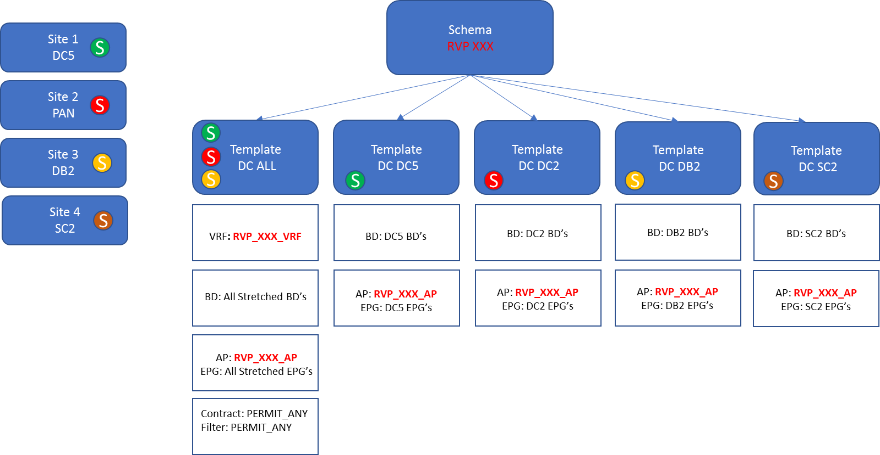

PS: We have to pay attention that only 500 policy objects per schema are supported.

An attempt to create more than 500 objects will generate an error message :

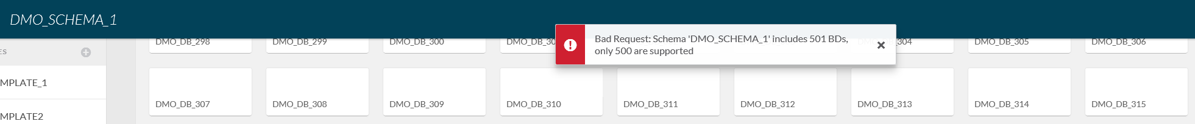

## Data Model and multi-tenancy

On each fabric we can have several tenants. At MSC level, a specific administrator account will also be created for each entity hosted on a given fabric :

|  |  |  |
| --- | --- | --- |
| Fabric | Entity | Account |
| **ALD** | ALD | ADMIN_ALD |
| **ASSU** | ASSU | ADMIN_ASSU |
| **RETAIL** | BDDF | ADMIN_BDDF |
| CDN | ADMIN_CDN |
| BSC | ADMIN_BSC |
| **MARKET** | SGCIB | ADMIN_SGCIB |
| SGSS | ADMIN_SGSS |
| CGA | ADMIN_CGA |
| **PLATFORM** | CLOUD | ADMIN_CLOUD |
| WORKPLACE | ADMIN_WORKPLACE |
| BIGDATA | ADMIN_BIGDATA |
| SHARED | ADMIN_SHARED |

We will deploy on each MSC several schemas (1 per VRF of each tenant) in which we will configure up to 5 templates (up to 4 single sites with a “multisite stretch” template can be manage with such a datamodel) :



We have up to 4 tenants on a fabric. Each fabric is made up of 3 sites max. It means each schema is consuming 4 templates. As we can’t overtake 200 templates, we can define 50 schemas. Approximately 12 per tenants (it means we can manage up to 12 VRF per tenant in a worst case).

We are not able to manage a tenant that will be spread on all sites of a fabric made up of 5 sites.

/!\ : port binding is also made with MSC. RBAC rules on port binding are not enforced at MSC level (**RBAC rules enforced at APIC level are useless**).

# Fabric interconnexion

## BGP AS Number

### Overview

In ACI target architecture we will have 3 routing domains :

* MAN network : a single routing domain using MPLS
* ACI multifabrics : each multi fabric is a single routing domain
* N7K routers used for ACI routing workaround : each multifabric has its set of N7K routers



It has been decided to use a single AS for all multifabrics.

MAN MPLS infrastructure will be responsible to avoid L3 routing loop between multi-fabrics using site of origin and AS overriding.

BGP AS override and SOO mechanisms won’t be used into ACI Border Leaf.

### Multisite Workaround and BGP setup

#### BGP use cases involving N7K

In order to solve some limitations currently identified in Cisco ACI multisite solution, some external routers (N7K) will be used. IP routing between each POD and these external routers will be either static or dynamic. When dynamic IP routing is required, BGP protocol will be used.

Currently following uses cases requiring BGP routing are currently identified :

1 - **Firewall acting as gateway for servers, Dual site**

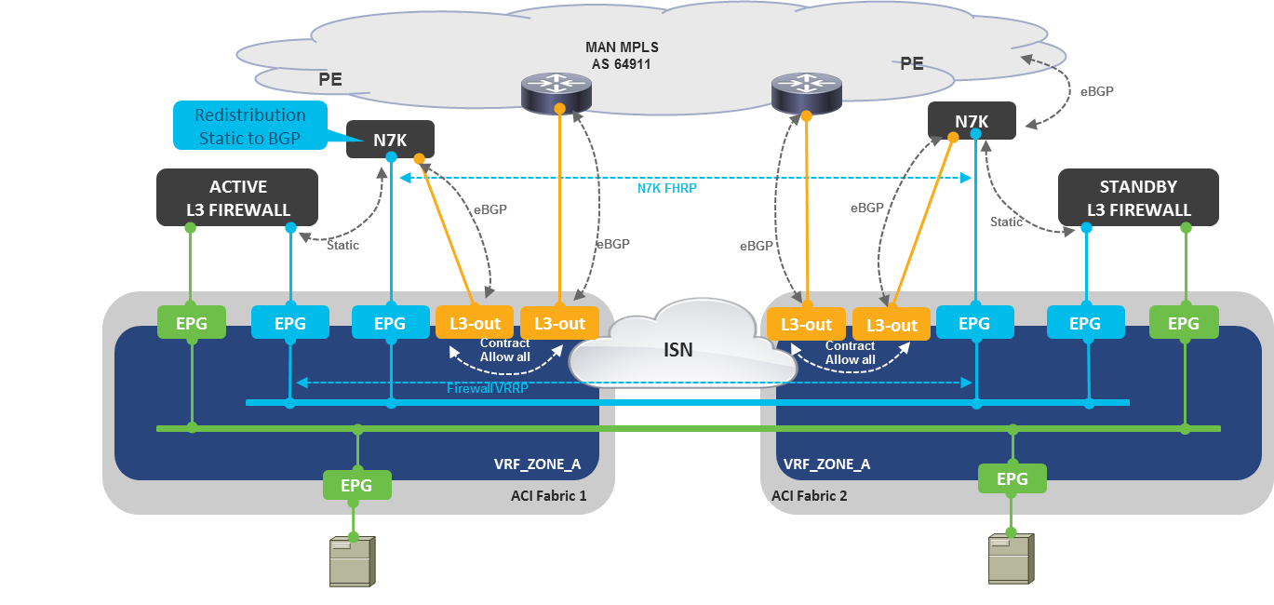

*BGP announcements* :

* Fabric to N7K : default route (0.0.0.0/0)
* N7K to fabric : DMZ ip ranges

2 - **OneArm-RoutedVIP-LocalCluster (single site):**

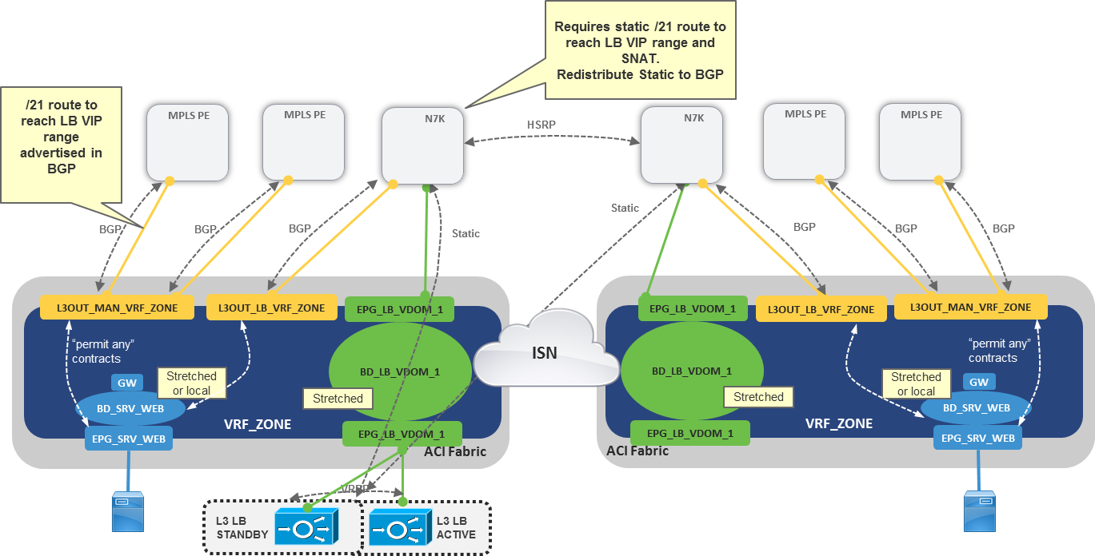

*BGP announcements* :

* Fabric to N7K : default route (0.0.0.0/0)
* N7K to fabric : VIP ip ranges

3 - **OneArm-RoutedVIP-stretched Cluster (dual site)**



*BGP announcements* :

* Fabric to N7K : default route (0.0.0.0/0)
* N7K to fabric : VIP ip ranges

3 – **Multicast traffic filtering (dual site)**

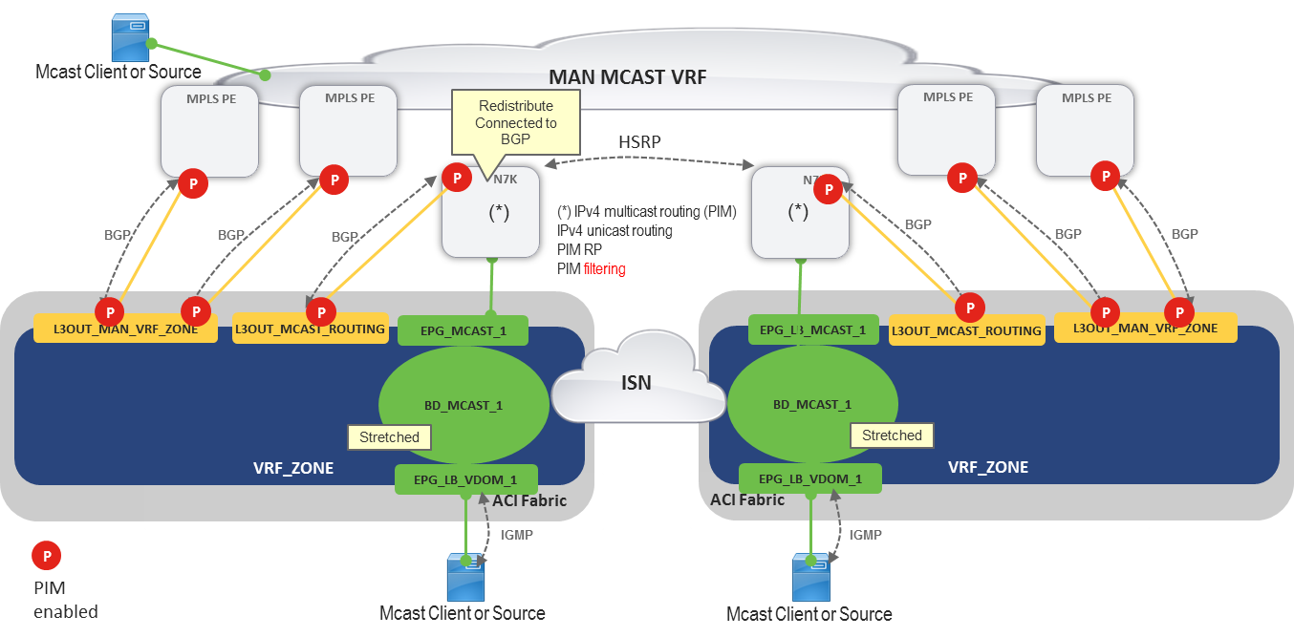

*BGP announcements* :

* Fabric to N7K : default route (0.0.0.0/0)
* N7K to fabric : Multicast LAN ip ranges

#### ACI routing workaround BGP design

A unique AS number should be enough for All VRF lite hosted onto a same multifabric as :

* Only a default route will be announced from the Fabric to each N7K VRF lite
* Each VRF lite pair of router will either :
  + Generate non overlapping IP ranges into the same fabric VRFs
  + Generate overlapping IP ranges into distinct fabric VRFs



### Multisite Workarround AS numbering

BGP is used for IP route exchange between ACI fabric and some network function hosted onto an external N7K router.



*BGP announcements* :

* Fabric to N7K : default route (0.0.0.0/0)
* N7K to fabric : Connected and/or static LAN ip ranges

One single AS will be used for each multi-site fabric :

|  |  |
| --- | --- |
| Multi-Site Fabrics | Work around AS number |
| ASSU | 64 967 |
| RETAIL | 64 968 |
| ALD | 64 969 |
| MARKET | 64 970 |
| PLATFORM | 64 971 |

**Inter-fabric workaround BGP IP announcement** :



**Intra-fabric workaround BGP IP announcement** :



### Internal AS number

One unique BGP AS number will be used for all fabrics : 64966.



**All SPINE nodes will be route reflectors.**

### External AS number

One unique BGP AS number will be used on all fabrics for L3Out configuration : 64919.



## “permit any” contract

A specific L3Out object is configured on each fabric POD on which a specific VRF interconnexion is needed with the MAN.



A specific contract will be also configured and used to manage MAN VRF access (and thus the IP route to be announced by the Fabric to the MAN).

Contract Name : PermitAny_<VRF Name>

## OSPF Interco for ISN

A specific OSPF area will be used for each ISN and for each routing plane.



A unique OSPF area number will be used (OSPF area 0). Each multi-site fabric will be linked to a single MAN VRF for intersite traffic transport.

|  |  |  |
| --- | --- | --- |
| Fabric Code | Multi Site ID | ISN Transport VRF |
| ASU | 01 | **RVP_ISN_ASU** |
| RET | 02 | **RVP_ISN_RET** |
| ALD | 04 | **RVP_ISN_ALD** |
| MKT | 05 | **RVP_ISN_MKT** |
| PLT | 06 | **RVP_ISN_PLT** |

IP Ranges allocated for OSPF point to point interconnexion are : 192.4.242.0/23 and 192.4.244.0/24

* ASU Fabric : 192.4.242.0/25
* RET Fabric : 192.4.242.128/25
* ALD Fabric : 192.4.243.0/25
* MKT Fabric : 192.4.243.128/25
* PLT Fabric : 192.4.244.0/25

PS : Interconnection interfaces will be configured with a 9100 MTU value with dot1q 4 VLAN tag.

* **First IP address (odd value)** of interconnection subnet will be configured on MAN side (X.X.X.1)
* **Second IP address (even value)** of interconnection subnet will be configured on ACI side (X.X.X.2)

|  |  |  |  |  |  |
| --- | --- | --- | --- | --- | --- |
| Fabric Code | DC |  | Routing Plane | OSPF Area | Interco IP |
| ASU | DC2 | SIPNE 1 | RED | 0 | 192.4.242.0/30 |
| BLUE | 0 | 192.4.242.4/30 |
| SPINE 2 | RED | 0 | 192.4.242.8/30 |
| BLUE | 0 | 192.4.242.12/30 |
| SPINE 3 | RED | 0 | 192.4.242.16/30 |
| BLUE | 0 | 192.4.242.20/30 |
| DB2 | SIPNE 1 | RED | 0 | 192.4.242.24/30 |
| BLUE | 0 | 192.4.242.28/30 |
| SPINE 2 | RED | 0 | 192.4.242.32/30 |
| BLUE | 0 | 192.4.242.36/30 |
| SPINE 3 | RED | 0 | 192.4.242.40/30 |
| BLUE | 0 | 192.4.242.44/30 |

|  |  |  |  |  |  |
| --- | --- | --- | --- | --- | --- |
| Fabric Code | DC |  | Routing Plane | OSPF Area | Interco IP |
| RET | DC2 | SIPNE 1 | RED | 0 | 192.4.242.128/30 |
| BLUE | 0 | 192.4.242.132/30 |
| SPINE 2 | RED | 0 | 192.4.242.136/30 |
| BLUE | 0 | 192.4.242.140/30 |
| SPINE 3 | RED | 0 | 192.4.242.144/30 |
| BLUE | 0 | 192.4.242.148/30 |
| DB2 | SIPNE 1 | RED | 0 | 192.4.242.152/30 |
| BLUE | 0 | 192.4.242.156/30 |
| SPINE 2 | RED | 0 | 192.4.242.160/30 |
| BLUE | 0 | 192.4.242.164/30 |
| SPINE 3 | RED | 0 | 192.4.242.168/30 |
| BLUE | 0 | 192.4.242.172/30 |
| SC2 | SIPNE 1 | RED | 0 | 192.4.242.176/30 |
| BLUE | 0 | 192.4.242.180/30 |
| SPINE 2 | RED | 0 | 192.4.242.184/30 |
| BLUE | 0 | 192.4.242.188/30 |
| SPINE 3 | RED | 0 | 192.4.242.192/30 |
| BLUE | 0 | 192.4.242.196/30 |
| DC5 | SIPNE 1 | RED | 0 | 192.4.242.200/30 |
| BLUE | 0 | 192.4.242.204/30 |
| SPINE 2 | RED | 0 | 192.4.242.208/30 |
| BLUE | 0 | 192.4.242.212/30 |
| SPINE 3 | RED | 0 | 192.4.242.216/30 |
| BLUE | 0 | 192.4.242.220/30 |

|  |  |  |  |  |  |
| --- | --- | --- | --- | --- | --- |
| Fabric Code | DC |  | Routing Plane | OSPF Area | Interco IP |
| ALD | DC5 | SIPNE 1 | RED | 0 | 192.4.243.0/30 |
| BLUE | 0 | 192.4.243.4/30 |
| SPINE 2 | RED | 0 | 192.4.243.8/30 |
| BLUE | 0 | 192.4.243.12/30 |
| SPINE 3 | RED | 0 | 192.4.243.16/30 |
| BLUE | 0 | 192.4.243.20/30 |
| PAN | SIPNE 1 | RED | 0 | 192.4.243.24/30 |
| BLUE | 0 | 192.4.243.28/30 |
| SPINE 2 | RED | 0 | 192.4.243.32/30 |
| BLUE | 0 | 192.4.243.36/30 |
| SPINE 3 | RED | 0 | 192.4.243.40/30 |
| BLUE | 0 | 192.4.243.44/30 |

|  |  |  |  |  |  |
| --- | --- | --- | --- | --- | --- |
| Fabric Code | DC |  | Routing Plane | OSPF Area | Interco IP |
| MKT | DCX | SIPNE 1 | RED | 0 | 192.4.243.128/30 |
| BLUE | 0 | 192.4.243.132/30 |
| SPINE 2 | RED | 0 | 192.4.243.136/30 |
| BLUE | 0 | 192.4.243.140/30 |
| SPINE 3 | RED | 0 | 192.4.243.144/30 |
| BLUE | 0 | 192.4.243.148/30 |
| PAN | SIPNE 1 | RED | 0 | 192.4.243.152/30 |
| BLUE | 0 | 192.4.243.156/30 |
| SPINE 2 | RED | 0 | 192.4.243.160/30 |
| BLUE | 0 | 192.4.243.164/30 |
| SPINE 3 | RED | 0 | 192.4.243.168/30 |
| BLUE | 0 | 192.4.243.172/30 |

|  |  |  |  |  |  |
| --- | --- | --- | --- | --- | --- |
| Fabric Code | DC |  | Routing Plane | OSPF Area | Interco IP |
| PLT | DC5 | SIPNE 1 | RED | 0 | 192.4.244.0/30 |
| BLUE | 0 | 192.4.244.4/30 |
| SPINE 2 | RED | 0 | 192.4.244.8/30 |
| BLUE | 0 | 192.4.244.12/30 |
| SPINE 3 | RED | 0 | 192.4.244.16/30 |
| BLUE | 0 | 192.4.244.20/30 |
| PAN | SIPNE 1 | RED | 0 | 192.4.244.24/30 |
| BLUE | 0 | 192.4.244.28/30 |
| SPINE 2 | RED | 0 | 192.4.244.32/30 |
| BLUE | 0 | 192.4.244.36/30 |
| SPINE 3 | RED | 0 | 192.4.244.40/30 |
| BLUE | 0 | 192.4.244.44/30 |
| SC2 | SIPNE 1 | RED | 0 | 192.4.244.48/30 |
| BLUE | 0 | 192.4.244.52/30 |
| SPINE 2 | RED | 0 | 192.4.244.56/30 |
| BLUE | 0 | 192.4.244.60/30 |
| SPINE 3 | RED | 0 | 192.4.244.64/30 |
| BLUE | 0 | 192.4.244.68/30 |

# Device Urbanization

## Spine switches

### Naming convention

<Fabric Code>-**SPN**-<Site Code>-<Room Code>-<Node ID>

As currently, only 3 SPINES will 1001, 1002, 1003 node IDs are foreseen, following SPINE switches naming will be used for each POD :

* <Fabric Code>-**SPN**-<Site Code>-<Room Code>-100**1**
* <Fabric Code>-**SPN**-<Site Code>-<Room Code>-100**2**
* <Fabric Code>-**SPN**-<Site Code>-<Room Code>-100**3**

*Example* :

ASU-SPN-DB2-B2D-1001

### Baby Spine nodes Generic port allocation (9364C)

|  |  |  |  |  |
| --- | --- | --- | --- | --- |
| **Device A (SPINE)** | **Port** | **Device B** | **Port** | **Interface Type** |
| <Fabric Code>-**SPN**-<Site Code>-<Room Code>-100**1** | 1/1 | <Fabric Code>-**BRD**-<Site Code>-<Room Code>-0**1**0**1** | 1/30 | QSFP-40/100-SRBD |
| 1/31 | <Fabric Code>-**BRD**-<Site Code>-<Room Code>-0**2**0**1** | 1/30 | QSFP-40/100-SRBD |
| 1/2 | <Fabric Code>-**SRV**-<Site Code>-<Room Code>-0**1**0**2** | 1/49 | QSFP-40/100-SRBD |
| 1/32 | <Fabric Code>-**SRV**-<Site Code>-<Room Code>-0**2**0**2** | 1/49 | QSFP-40/100-SRBD |
| … |  |  |  |
| **1**/**P** | <Fabric Code>-**LEF**-<Site Code>-<Room Code>-0**1**0**P** | **1**/**30 or 1/49** | QSFP-40/100-SRBD |
| … |  |  |  |
| **1**/**20+P (*)** | <Fabric Code>-**LEF**-<Site Code>-<Room Code>-0**7**0**P** | **1**/**30 or 1/49** | QSFP-40/100-SRBD |
| … |  |  |  |
| **1/30+P** | <Fabric Code>-**LEF**-<Site Code>-<Room Code>-0**2**0**P** | **1**/**30 or 1/49** | QSFP-40/100-SRBD |
| … |  |  |  |
| **1/50+P**  **(*)** | <Fabric Code>-**LEF**-<Site Code>-<Room Code>-0**8**0**P** | **1**/**30 or 1/49** | QSFP-40/100-SRBD |
| … |  |  |  |
| 1/63 | MAN PE1 – *Plane A (ISN)* | - | QSFP-100G-LR4-S |
| 1/64 | MAN PE1 – *Plane B (ISN)* | - | QSFP-100G-LR4-S |
| Mgnt1 | OOB Switch | - | 1G RJ45 |
| ~~Mgnt2~~ | ~~OOB Switch~~ | ~~-~~ | ~~1G RJ45~~ |
| Con1 | - | - | Serial 9600 RJ45 |
| ~~Con2~~ | ~~-~~ | ~~-~~ | ~~Serial 9600 RJ45~~ |

(*) Up to 20 production switch pairs and 20 inband management switches.

|  |  |  |  |  |
| --- | --- | --- | --- | --- |
| **Device A (SPINE)** | **Port** | **Device B** | **Port** | **Interface Type** |
| <Fabric Code>-**SPN**-<Site Code>-<Room Code>-100**2** | 1/1 | <Fabric Code>-**BRD**-<Site Code>-<Room Code>-0**1**0**1** | 1/31 | QSFP-40/100-SRBD |
| 1/31 | <Fabric Code>-**BRD**-<Site Code>-<Room Code>-0**2**0**1** | 1/31 | QSFP-40/100-SRBD |
| 1/2 | <Fabric Code>-**SRV**-<Site Code>-<Room Code>-0**1**0**2** | 1/50 | QSFP-40/100-SRBD |
| 1/32 | <Fabric Code>-**SRV**-<Site Code>-<Room Code>-0**2**0**2** | 1/50 | QSFP-40/100-SRBD |
| … |  |  |  |
| **1**/**P** | <Fabric Code>-**LEF**-<Site Code>-<Room Code>-0**1**0**P** | **1**/**31 or 1/50** | QSFP-40/100-SRBD |
| … |  |  |  |
| **1**/**20+P**  **(*)** | <Fabric Code>-**LEF**-<Site Code>-<Room Code>-0**7**0**P** | **1**/**31 or 1/50** | QSFP-40/100-SRBD |
| … |  |  |  |
| **1/30+P** | <Fabric Code>-**LEF**-<Site Code>-<Room Code>-0**2**0**P** | **1**/**31 or 1/50** | QSFP-40/100-SRBD |
| … |  |  |  |
| **1/50+P**  **(*)** | <Fabric Code>-**LEF**-<Site Code>-<Room Code>-0**8**0**P** | **1**/**31 or 1/50** | QSFP-40/100-SRBD |
| … |  |  |  |
| 1/63 | MAN PE1 – *Plane A (ISN)* | - | QSFP-100G-LR4-S |
| 1/64 | MAN PE1 – *Plane B (ISN)* | - | QSFP-100G-LR4-S |
| Mgnt1 | OOB Switch | - | 1G RJ45 |
| ~~Mgnt2~~ | ~~OOB Switch~~ | ~~-~~ | ~~1G RJ45~~ |
| Con1 | - | - | Serial 9600 RJ45 |
| ~~Con2~~ | ~~-~~ | ~~-~~ | ~~Serial 9600 RJ45~~ |

(*) Up to 20 production switch pairs and 20 inband management switches.

|  |  |  |  |  |
| --- | --- | --- | --- | --- |
| **Device A (SPINE)** | **Port** | **Device B** | **Port** | **Interface Type** |
| <Fabric Code>-**SPN**-<Site Code>-<Room Code>-100**3** | 1/1 | <Fabric Code>-**BRD**-<Site Code>-<Room Code>-0**1**0**1** | 1/32 | QSFP-40/100-SRBD |
| 1/31 | <Fabric Code>-**BRD**-<Site Code>-<Room Code>-0**2**0**1** | 1/32 | QSFP-40/100-SRBD |
| 1/2 | <Fabric Code>-**SRV**-<Site Code>-<Room Code>-0**1**0**2** | 1/51 | QSFP-40/100-SRBD |
| 1/32 | <Fabric Code>-**SRV**-<Site Code>-<Room Code>-0**2**0**2** | 1/51 | QSFP-40/100-SRBD |
| … |  |  |  |
| **1**/**P** | <Fabric Code>-**LEF**-<Site Code>-<Room Code>-0**1**0**P** | **1**/**32 or 1/51** | QSFP-40/100-SRBD |
| … |  |  |  |
| **1**/**20+P**  **(*)** | <Fabric Code>-**LEF**-<Site Code>-<Room Code>-0**7**0**P** | **1**/**32 or 1/51** | QSFP-40/100-SRBD |
| … |  |  |  |
| **1/30+P** | <Fabric Code>-**LEF**-<Site Code>-<Room Code>-0**2**0**P** | **1**/**32 or 1/51** | QSFP-40/100-SRBD |
| … |  |  |  |
| **1/50+P**  **(*)** | <Fabric Code>-**LEF**-<Site Code>-<Room Code>-0**8**0**P** | **1**/**32 or 1/51** | QSFP-40/100-SRBD |
| … |  |  |  |
| 1/63 | MAN PE1 – *Plane A (ISN)* | - | QSFP-100G-LR4-S |
| 1/64 | MAN PE1 – *Plane B (ISN)* | - | QSFP-100G-LR4-S |
| Mgnt1 | OOB Switch | - | 1G RJ45 |
| ~~Mgnt2~~ | ~~OOB Switch~~ | ~~-~~ | ~~1G RJ45~~ |
| Con1 | - | - | Serial 9600 RJ45 |
| ~~Con2~~ | ~~-~~ | ~~-~~ | ~~Serial 9600 RJ45~~ |

(*) Up to 20 production switch pairs and 20 inband management switches.

### 8 slots Spine nodes Generic port allocation (C9508)

|  |  |  |  |  |
| --- | --- | --- | --- | --- |
| **Device A (SPINE)** | **Port** | **Device B** | **Port** | **Interface Type** |
| <Fabric Code>-**SPN**-<Site Code>-<Room Code>-100**1** | **1**/**1** | <Fabric Code>-**BRD**-<Site Code>-<Room Code>-0**1**0**1** | 1/30 | QSFP-40/100-SRBD |
| **2**/**1** | <Fabric Code>-**BRD**-<Site Code>-<Room Code>-0**2**0**1** | 1/30 | QSFP-40/100-SRBD |
| **1**/**2** | <Fabric Code>-**SRV**-<Site Code>-<Room Code>-0**1**0**2** | 1/49 | QSFP-40/100-SRBD |
| **2**/**2** | <Fabric Code>-**SRV**-<Site Code>-<Room Code>-0**2**0**2** | 1/49 | QSFP-40/100-SRBD |
| … |  |  |  |
| **S**/**P** | <Fabric Code>-**LEF**-<Site Code>-<Room Code>-0**S**0**P** | **1**/**30 or 1/49** | QSFP-40/100-SRBD |
| … |  |  |  |
| **7**/**P** | <Fabric Code>-**LEF**-<Site Code>-<Room Code>-0**7**0**P** | **1**/**30 or 1/49** | QSFP-40/100-SRBD |
| **8**/**P** | <Fabric Code>-**LEF**-<Site Code>-<Room Code>-0**8**0**P** | **1**/**30 or 1/49** | QSFP-40/100-SRBD |
| 1/36 | MAN PE1 – *Plane A (ISN)* | - | QSFP-100G-LR4-S |
| 2/36 | MAN PE1 – *Plane B (ISN)* | - | QSFP-100G-LR4-S |
| Mgnt1 | OOB Switch | - | 1G RJ45 |
| Mgnt2 | OOB Switch | - | 1G RJ45 |
| Con1 | - | - | Serial 9600 RJ45 |
| Con2 | - | - | Serial 9600 RJ45 |

|  |  |  |  |  |
| --- | --- | --- | --- | --- |
| **Device A (SPINE)** | **Port** | **Device B** | **Port** | **Interface Type** |
| <Fabric Code>-**SPN**-<Site Code>-<Room Code>-100**2** | **1**/**1** | <Fabric Code>-**BRD**-<Site Code>-<Room Code>-0**1**0**1** | 1/31 | QSFP-40/100-SRBD |
| **2**/**1** | <Fabric Code>-**BRD**-<Site Code>-<Room Code>-0**2**0**1** | 1/31 | QSFP-40/100-SRBD |
| **1**/**2** | <Fabric Code>-**SRV**-<Site Code>-<Room Code>-0**1**0**2** | 1/50 | QSFP-40/100-SRBD |
| **2**/**2** | <Fabric Code>-**SRV**-<Site Code>-<Room Code>-0**2**0**2** | 1/50 | QSFP-40/100-SRBD |
| … |  |  |  |
| **S**/**P** | <Fabric Code>-**LEF**-<Site Code>-<Room Code>-0**S**0**P** | **1**/**31 or 1/50** | QSFP-40/100-SRBD |
| … |  |  |  |
| **7**/**P** | <Fabric Code>-**LEF**-<Site Code>-<Room Code>-0**7**0**P** | **1**/**31 or 1/50** | QSFP-40/100-SRBD |
| **8**/**P** | <Fabric Code>-**LEF**-<Site Code>-<Room Code>-0**8**0**P** | **1**/**31 or 1/50** | QSFP-40/100-SRBD |
| 1/36 | MAN PE1 – *Plane A (ISN)* | - | QSFP-100G-LR4-S |
| 2/36 | MAN PE1 – *Plane B (ISN)* | - | QSFP-100G-LR4-S |
| Mgnt1 | OOB Switch | - | 1G RJ45 |
| Mgnt2 | OOB Switch | - | 1G RJ45 |
| Con1 | - | - | Serial 9600 RJ45 |
| Con2 | - | - | Serial 9600 RJ45 |

|  |  |  |  |  |
| --- | --- | --- | --- | --- |
| **Device A (SPINE)** | **Port** | **Device B** | **Port** | **Interface Type** |
| <Fabric Code>-**SPN**-<Site Code>-<Room Code>-100**3** | **1**/**1** | <Fabric Code>-**BRD**-<Site Code>-<Room Code>-0**1**0**1** | 1/32 | QSFP-40/100-SRBD |
| **2**/**1** | <Fabric Code>-**BRD**-<Site Code>-<Room Code>-0**2**0**1** | 1/32 | QSFP-40/100-SRBD |
| **1**/**2** | <Fabric Code>-**SRV**-<Site Code>-<Room Code>-0**1**0**2** | 1/51 | QSFP-40/100-SRBD |
| **2**/**2** | <Fabric Code>-**SRV**-<Site Code>-<Room Code>-0**2**0**2** | 1/51 | QSFP-40/100-SRBD |
| … |  |  |  |
| **S**/**P** | <Fabric Code>-**LEF**-<Site Code>-<Room Code>-0**S**0**P** | **1**/**32 or 1/51** | QSFP-40/100-SRBD |
| … |  |  |  |
| **7**/**P** | <Fabric Code>-**LEF**-<Site Code>-<Room Code>-0**7**0**P** | **1**/**32 or 1/51** | QSFP-40/100-SRBD |
| **8**/**P** | <Fabric Code>-**LEF**-<Site Code>-<Room Code>-0**8**0**P** | **1**/**32 or 1/51** | QSFP-40/100-SRBD |
| 1/36 | MAN PE1 – *Plane A (ISN)* | - | QSFP-100G-LR4-S |
| 2/36 | MAN PE1 – *Plane B (ISN)* | - | QSFP-100G-LR4-S |
| Mgnt1 | OOB Switch | - | 1G RJ45 |
| Mgnt2 | OOB Switch | - | 1G RJ45 |
| Con1 | - | - | Serial 9600 RJ45 |
| Con2 | - | - | Serial 9600 RJ45 |

## Leaf switches

### Naming Convention :

* User Leaf Production Switch :  
  <Fabric Code>-**LEF**-<Site Code>-<Room Code>-<Node-ID>
* User Leaf inband management Switch :  
  <Fabric Code>-**LEF**-<Site Code>-<Room Code>-<Node-ID>
* Service Leaf Switch :  
  <Fabric Code>-**SRV**-<Site Code>-<Room Code>-<Node-ID>
* Border Leaf Switch :  
  <Fabric Code>-**BRD**-<Site Code>-<Room Code>-<Node-ID>

*Example* :

ASU-LEF-DB2-B2D-0101

### Leaf nodes Generic port allocation

#### N9K-C93180LC-EX leaf

This kind of switch is used for high speed fiber connectivity (40G/50G).

This is a 32 ports device with 100G QSFP28

|  |  |  |  |  |
| --- | --- | --- | --- | --- |
| **Device A (LEAF)** | **Port** | **Device B** | **Port** | **Interface Type** |
| <Fabric Code>-**XXX**-<Site Code>-<Room Code>-0101 | 1/30 | <Fabric Code>-**SPN**-<Site Code>-<Room Code>-100**1** | 1/1 | QSFP-40/100-SRBD |
| 1/31 | <Fabric Code>-**SPN**-<Site Code>-<Room Code>-100**2** | 1/1 | QSFP-40/100-SRBD |
| 1/32 | <Fabric Code>-**SPN**-<Site Code>-<Room Code>-100**3** | 1/1 | QSFP-40/100-SRBD |
| 1/25 | <Fabric Code>-**SPN**-<Site Code>-<Room Code>-100**1** | - | QSFP-40/100-SRBD |
| 1/27 | <Fabric Code>-**SPN**-<Site Code>-<Room Code>-100**2** | - | QSFP-40/100-SRBD |
| 1/29 | <Fabric Code>-**SPN**-<Site Code>-<Room Code>-100**3** | - | QSFP-40/100-SRBD |
| Mgnt | OOB Switch | - | 1G RJ45 |
| Con | - | - | Serial 9600 RJ45 |

|  |  |  |  |  |
| --- | --- | --- | --- | --- |
| **Device A (LEAF)** | **Port** | **Device B** | **Port** | **Interface Type** |
| <Fabric Code>-**XXX**-<Site Code>-<Room Code>-0**S**0**P** | 1/30 | <Fabric Code>-**SPN**-<Site Code>-<Room Code>-100**1** | **S**/**P** | QSFP-40/100-SRBD |
| 1/31 | <Fabric Code>-**SPN**-<Site Code>-<Room Code>-100**2** | **S**/**P** | QSFP-40/100-SRBD |
| 1/32 | <Fabric Code>-**SPN**-<Site Code>-<Room Code>-100**3** | **S**/**P** | QSFP-40/100-SRBD |
| 1/25 | <Fabric Code>-**SPN**-<Site Code>-<Room Code>-100**1** | - | QSFP-40/100-SRBD |
| 1/27 | <Fabric Code>-**SPN**-<Site Code>-<Room Code>-100**2** | - | QSFP-40/100-SRBD |
| 1/29 | <Fabric Code>-**SPN**-<Site Code>-<Room Code>-100**3** | - | QSFP-40/100-SRBD |
| Mgnt | OOB Switch | - | 1G RJ45 |
| Con | - | - | Serial 9600 RJ45 |

PS1 : XXX has to be replaced by the Leaf Device Code (LEF, SRV or BRD)

PS2: On each leaf, 1/27, 1/28 and 1/29 QSFP ports are booked for a future capacity upgrade need.

PS3 : Port 26 and 28 can’t be used.

PS4 : depending on QSFP interface used, some ports numbers are not available :

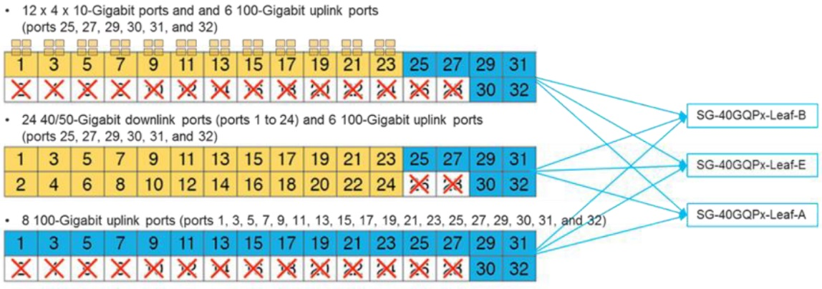

#### N9K-C93180YC-FX leaf

This kind of switch is used for low speed fiber and copper connectivity (1G/10G/25G).

This is a 48 SFP user ports and 6 x 100G QSFP uplink ports.

|  |  |  |  |  |
| --- | --- | --- | --- | --- |
| **Device A (LEAF)** | **Port** | **Device B** | **Port** | **Interface Type** |
| <Fabric Code>-**XXX**-<Site Code>-<Room Code>-0101 | 1/49 | <Fabric Code>-**SPN**-<Site Code>-<Room Code>-100**1** | 1/1 | QSFP-40/100-SRBD |
| 1/50 | <Fabric Code>-**SPN**-<Site Code>-<Room Code>-100**2** | 1/1 | QSFP-40/100-SRBD |
| 1/51 | <Fabric Code>-**SPN**-<Site Code>-<Room Code>-100**3** | 1/1 | QSFP-40/100-SRBD |
| 1/52 | <Fabric Code>-**SPN**-<Site Code>-<Room Code>-100**1** | - | QSFP-40/100-SRBD |
| 1/53 | <Fabric Code>-**SPN**-<Site Code>-<Room Code>-100**2** | - | QSFP-40/100-SRBD |
| 1/54 | <Fabric Code>-**SPN**-<Site Code>-<Room Code>-100**3** | - | QSFP-40/100-SRBD |
| Mgnt | OOB Switch | - | 1G RJ45 |
| Con | - | - | Serial 9600 RJ45 |

|  |  |  |  |  |
| --- | --- | --- | --- | --- |
| **Device A (LEAF)** | **Port** | **Device B** | **Port** | **Interface Type** |
| <Fabric Code>-**XXX**-<Site Code>-<Room Code>-0**S**0**P** | 1/49 | <Fabric Code>-**SPN**-<Site Code>-<Room Code>-100**1** | **S**/**P** | QSFP-40/100-SRBD |
| 1/50 | <Fabric Code>-**SPN**-<Site Code>-<Room Code>-100**2** | **S**/**P** | QSFP-40/100-SRBD |
| 1/51 | <Fabric Code>-**SPN**-<Site Code>-<Room Code>-100**3** | **S**/**P** | QSFP-40/100-SRBD |
| 1/52 | <Fabric Code>-**SPN**-<Site Code>-<Room Code>-100**1** | - | QSFP-40/100-SRBD |
| 1/53 | <Fabric Code>-**SPN**-<Site Code>-<Room Code>-100**2** | - | QSFP-40/100-SRBD |
| 1/54 | <Fabric Code>-**SPN**-<Site Code>-<Room Code>-100**3** | - | QSFP-40/100-SRBD |
| Mgnt | OOB Switch | - | 1G RJ45 |
| Con | - | - | Serial 9600 RJ45 |

PS1 : XXX has to be replaced by the Leaf Device Code (LEF, SRV or BRD)

PS2: On each leaf, 1/52, 1/53 and 1/54 QSFP ports are booked for a future capacity upgrade need.

#### N9K-C93108TC-FX leaf

This kind of switch is mainly used for inband management purpose (10G copper ports only).

This is a 48 ports 10G-T and 6 ports 100G QSFP.

|  |  |  |  |  |
| --- | --- | --- | --- | --- |
| **Device A (LEAF)** | **Port** | **Device B** | **Port** | **Interface Type** |
| <Fabric Code>-**XXX**-<Site Code>-<Room Code>-0101 | 1/49 | <Fabric Code>-**SPN**-<Site Code>-<Room Code>-100**1** | 1/1 | QSFP-40/100-SRBD |
| 1/50 | <Fabric Code>-**SPN**-<Site Code>-<Room Code>-100**2** | 1/1 | QSFP-40/100-SRBD |
| 1/51 | <Fabric Code>-**SPN**-<Site Code>-<Room Code>-100**3** | 1/1 | QSFP-40/100-SRBD |
| 1/52 | <Fabric Code>-**SPN**-<Site Code>-<Room Code>-100**1** | - | QSFP-40/100-SRBD |
| 1/53 | <Fabric Code>-**SPN**-<Site Code>-<Room Code>-100**2** | - | QSFP-40/100-SRBD |
| 1/54 | <Fabric Code>-**SPN**-<Site Code>-<Room Code>-100**3** | - | QSFP-40/100-SRBD |
| Mgnt | OOB Switch | - | 1G RJ45 |
| Con | - | - | Serial 9600 RJ45 |

|  |  |  |  |  |
| --- | --- | --- | --- | --- |
| **Device A (LEAF)** | **Port** | **Device B** | **Port** | **Interface Type** |
| <Fabric Code>-**XXX**-<Site Code>-<Room Code>-0**S**0**P** | 1/49 | <Fabric Code>-**SPN**-<Site Code>-<Room Code>-100**1** | **S**/**P** | QSFP-40/100-SRBD |
| 1/50 | <Fabric Code>-**SPN**-<Site Code>-<Room Code>-100**2** | **S**/**P** | QSFP-40/100-SRBD |
| 1/51 | <Fabric Code>-**SPN**-<Site Code>-<Room Code>-100**3** | **S**/**P** | QSFP-40/100-SRBD |
| 1/52 | <Fabric Code>-**SPN**-<Site Code>-<Room Code>-100**1** | - | QSFP-40/100-SRBD |
| 1/53 | <Fabric Code>-**SPN**-<Site Code>-<Room Code>-100**2** | - | QSFP-40/100-SRBD |
| 1/54 | <Fabric Code>-**SPN**-<Site Code>-<Room Code>-100**3** | - | QSFP-40/100-SRBD |
| Mgnt | OOB Switch | - | 1G RJ45 |
| Con | - | - | Serial 9600 RJ45 |

PS1 : XXX has to be replaced by the Leaf Device Code (LEF, SRV or BRD)

PS2: On each leaf, 1/27, 1/28 and 1/29 QSFP ports are booked for a future capacity upgrade need.

### Border Leaf Specific Allocation

Border Leaf switches are using N9K-C93180LC-EX nexus model.

On each site 2 border leaf switches will be deployed. ID 101 and 102 are booked for them (hence port 1/1 and 1/2 are used on SPINE side).

|  |  |  |  |  |
| --- | --- | --- | --- | --- |
| **Device A (LEAF)** | **Port** | **Device B** | **Port** | **Interface Type** |
| <Fabric Code>-**BRD**-<Site Code>-<Room Code>-0101 | 1/30 | <Fabric Code>-**SPN**-<Site Code>-<Room Code>-100**1** | 1/1 | QSFP-40/100-SRBD |
| 1/31 | <Fabric Code>-**SPN**-<Site Code>-<Room Code>-100**2** | 1/1 | QSFP-40/100-SRBD |
| 1/32 | <Fabric Code>-**SPN**-<Site Code>-<Room Code>-100**3** | 1/1 | QSFP-40/100-SRBD |
| 1/25 | <Fabric Code>-**SPN**-<Site Code>-<Room Code>-100**1** | - | QSFP-40/100-SRBD |
| 1/27 | <Fabric Code>-**SPN**-<Site Code>-<Room Code>-100**2** | - | QSFP-40/100-SRBD |
| 1/29 | <Fabric Code>-**SPN**-<Site Code>-<Room Code>-100**3** | - | QSFP-40/100-SRBD |
| 1/1 | MAN PE1 – *Plane A* | - | QSFP-100G-LR4-S |
| 1/2 | <Fabric Code>-**BRD**-<Site Code>-<Room Code>-0201 | 1/2 | QSFP-40/100-SRBD |
| 1/3 | <Fabric Code>-**BRD**-<Site Code>-<Room Code>-0201 | 1/3 | QSFP-40/100-SRBD |
| 1/4 | <Fabric Code>-**BRD**-<Site Code>-<Room Code>-0101 | 1/4 | QSFP-40/100-SRBD |
| 1/5 | <Fabric Code>-**BRD**-<Site Code>-<Room Code>-0101 | 1/1 | QSFP-40/100-SRBD |
| Mgnt | OOB Switch | - | 1G RJ45 |
| Con | - | - | Serial 9600 RJ45 |

|  |  |  |  |  |
| --- | --- | --- | --- | --- |
| **Device A (LEAF)** | **Port** | **Device B** | **Port** | **Interface Type** |
| <Fabric Code>-**BRD**-<Site Code>-<Room Code>-0201 | 1/30 | <Fabric Code>-**SPN**-<Site Code>-<Room Code>-100**1** | 2/1 | QSFP-40/100-SRBD |
| 1/31 | <Fabric Code>-**SPN**-<Site Code>-<Room Code>-100**2** | 2/1 | QSFP-40/100-SRBD |
| 1/32 | <Fabric Code>-**SPN**-<Site Code>-<Room Code>-100**3** | 2/1 | QSFP-40/100-SRBD |
| 1/25 | <Fabric Code>-**SPN**-<Site Code>-<Room Code>-100**1** | - | QSFP-40/100-SRBD |
| 1/27 | <Fabric Code>-**SPN**-<Site Code>-<Room Code>-100**2** | - | QSFP-40/100-SRBD |
| 1/29 | <Fabric Code>-**SPN**-<Site Code>-<Room Code>-100**3** | - | QSFP-40/100-SRBD |
| 1/1 | MAN PE2 – *Plane B* | - | QSFP-100G-LR4-S |
| 1/2 | <Fabric Code>-**BRD**-<Site Code>-<Room Code>-0101 | 1/2 | QSFP-40/100-SRBD |
| 1/3 | <Fabric Code>-**BRD**-<Site Code>-<Room Code>-0101 | 1/3 | QSFP-40/100-SRBD |
| 1/4 | <Fabric Code>-**BRD**-<Site Code>-<Room Code>-0201 | 1/4 | QSFP-40/100-SRBD |
| 1/5 | <Fabric Code>-**BRD**-<Site Code>-<Room Code>-0201 | 1/1 | QSFP-40/100-SRBD |
| Mgnt | OOB Switch | - | 1G RJ45 |
| Con | - | - | Serial 9600 RJ45 |

PS : Port 26 and 28 can’t be used.

100G QSFP ports are inserted into ODD ports. Associated EVEN ports are automatically disabled.

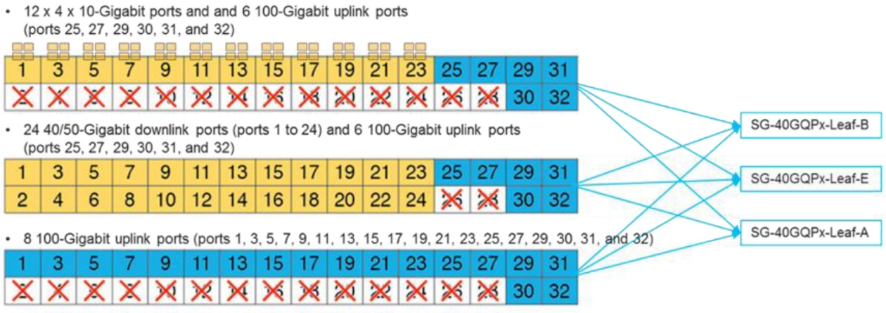

### Service Leaf Specific Allocation

Service Leaf switches are using N9K-C93180YC-FX nexus model.

On each site 2 service leaf switches will be deployed. ID 102 and 202 are booked for them (hence port 1/2 and 2/2 are used on SPINE side).

|  |  |  |  |  |
| --- | --- | --- | --- | --- |
| **Device A (LEAF)** | **Port** | **Device B** | **Port** | **Interface Type** |
| <Fabric Code>-**SRV**-<Site Code>-<Room Code>-0102 | 1/49 | <Fabric Code>-**SPN**-<Site Code>-<Room Code>-100**1** | 1/2 | QSFP-40/100-SRBD |
| 1/50 | <Fabric Code>-**SPN**-<Site Code>-<Room Code>-100**2** | 1/2 | QSFP-40/100-SRBD |
| 1/51 | <Fabric Code>-**SPN**-<Site Code>-<Room Code>-100**3** | 1/2 | QSFP-40/100-SRBD |
| 1/52 | <Fabric Code>-**SPN**-<Site Code>-<Room Code>-100**1** | - | QSFP-40/100-SRBD |
| 1/53 | <Fabric Code>-**SPN**-<Site Code>-<Room Code>-100**2** | - | QSFP-40/100-SRBD |
| 1/54 | <Fabric Code>-**SPN**-<Site Code>-<Room Code>-100**3** | - | QSFP-40/100-SRBD |
| 1/44 | <Fabric Code>-**APC**-<Site Code>-<Room Code>-0001 | 1/1 | SFP-10G-SR-S |
| 1/45 | <Fabric Code>-**APC**-<Site Code>-<Room Code>-0002 | 1/1 | SFP-10G-SR-S |
| 1/46 | <Fabric Code>-**APC**-<Site Code>-<Room Code>-0003 | 1/1 | SFP-10G-SR-S |
| 1/47 | <Fabric Code>-**APC**-<Site Code>-<Room Code>-0004 | 1/1 | SFP-10G-SR-S |
| 1/48 | <Fabric Code>-**APC**-<Site Code>-<Room Code>-0005 | 1/1 | SFP-10G-SR-S |
| Mgnt | OOB Switch | - | 1G RJ45 |
| Con | - | - | Serial 9600 RJ45 |
| 1/47 | <Fabric Code>-**APC**-<Site Code>-<Room Code>-0004 | 1/2 | SFP-10G-SR-S |
| 1/48 | <Fabric Code>-**APC**-<Site Code>-<Room Code>-0005 | 1/2 | SFP-10G-SR-S |
| Mgnt | OOB Switch | - | 1G RJ45 |
| Con | - | - | Serial 9600 RJ45 |

|  |  |  |  |  |
| --- | --- | --- | --- | --- |
| **Device A (LEAF)** | **Port** | **Device B** | **Port** | **Interface Type** |
| <Fabric Code>-**SRV**-<Site Code>-<Room Code>-0202 | 1/49 | <Fabric Code>-**SPN**-<Site Code>-<Room Code>-100**1** | 2/2 | QSFP-40/100-SRBD |
| 1/50 | <Fabric Code>-**SPN**-<Site Code>-<Room Code>-100**2** | 2/2 | QSFP-40/100-SRBD |
| 1/51 | <Fabric Code>-**SPN**-<Site Code>-<Room Code>-100**3** | 2/2 | QSFP-40/100-SRBD |
| 1/52 | <Fabric Code>-**SPN**-<Site Code>-<Room Code>-100**1** | - | QSFP-40/100-SRBD |
| 1/53 | <Fabric Code>-**SPN**-<Site Code>-<Room Code>-100**2** | - | QSFP-40/100-SRBD |
| 1/54 | <Fabric Code>-**SPN**-<Site Code>-<Room Code>-100**3** | - | QSFP-40/100-SRBD |
| 1/44 | <Fabric Code>-**APC**-<Site Code>-<Room Code>-0001 | 1/2 | SFP-10G-SR-S |
| 1/45 | <Fabric Code>-**APC**-<Site Code>-<Room Code>-0002 | 1/2 | SFP-10G-SR-S |
| 1/46 | <Fabric Code>-**APC**-<Site Code>-<Room Code>-0003 | 1/2 | SFP-10G-SR-S |
| 1/47 | <Fabric Code>-**APC**-<Site Code>-<Room Code>-0004 | 1/2 | SFP-10G-SR-S |
| 1/48 | <Fabric Code>-**APC**-<Site Code>-<Room Code>-0005 | 1/2 | SFP-10G-SR-S |
| Mgnt | OOB Switch | - | 1G RJ45 |
| Con | - | - | Serial 9600 RJ45 |

### Customer Leaf Standard Allocation

|  |  |  |  |  |
| --- | --- | --- | --- | --- |
| **Device A (LEAF)** | **Port** | **Device B** | **Port** | **Interface Type** |
| <Fabric Code>-**LEF**-<Site Code>-<Room Code>-010x | 1/49 | <Fabric Code>-**SPN**-<Site Code>-<Room Code>-100**1** | 1/3 | QSFP-40/100-SRBD |
| 1/50 | <Fabric Code>-**SPN**-<Site Code>-<Room Code>-100**2** | 1/3 | QSFP-40/100-SRBD |
| 1/51 | <Fabric Code>-**SPN**-<Site Code>-<Room Code>-100**3** | 1/3 | QSFP-40/100-SRBD |
| 1/52 | <Fabric Code>-**SPN**-<Site Code>-<Room Code>-100**1** | - | QSFP-40/100-SRBD |
| 1/53 | <Fabric Code>-**SPN**-<Site Code>-<Room Code>-100**2** | - | QSFP-40/100-SRBD |
| 1/54 | <Fabric Code>-**SPN**-<Site Code>-<Room Code>-100**3** | - | QSFP-40/100-SRBD |
| Mgnt | OOB Switch | - | 1G RJ45 |
| Con | - | - | Serial 9600 RJ45 |
|  |  |  |  |  |
| <Fabric Code>-**LEF**-<Site Code>-<Room Code>-020x | 1/49 | <Fabric Code>-**SPN**-<Site Code>-<Room Code>-100**1** | 2/3 | QSFP-40/100-SRBD |
| 1/50 | <Fabric Code>-**SPN**-<Site Code>-<Room Code>-100**2** | 2/3 | QSFP-40/100-SRBD |
| 1/51 | <Fabric Code>-**SPN**-<Site Code>-<Room Code>-100**3** | 2/3 | QSFP-40/100-SRBD |
| 1/52 | <Fabric Code>-**SPN**-<Site Code>-<Room Code>-100**1** | - | QSFP-40/100-SRBD |
| 1/53 | <Fabric Code>-**SPN**-<Site Code>-<Room Code>-100**2** | - | QSFP-40/100-SRBD |
| 1/54 | <Fabric Code>-**SPN**-<Site Code>-<Room Code>-100**3** | - | QSFP-40/100-SRBD |
| Mgnt | OOB Switch | - | 1G RJ45 |
| Con | - | - | Serial 9600 RJ45 |

### L2DCI OTV nodes for migration purpose

#### N7706 physical urbanization

Cisco 7706 is a 9RU switch with 4 payload slots :

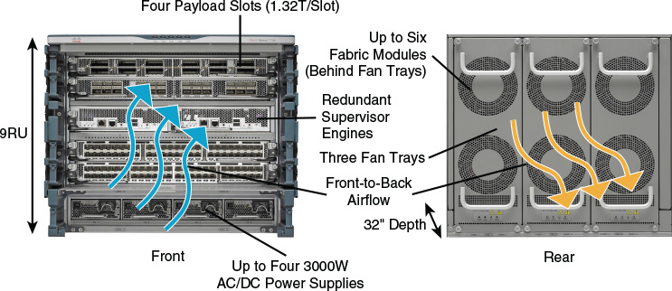

In slot 1 we will install a 24 x 40G line card and in slot 2 we will install a 48 x 10G line card :



#### N7702 physical urbanization

Cisco 7702 is a 3RU switch with 1 payload slot :

[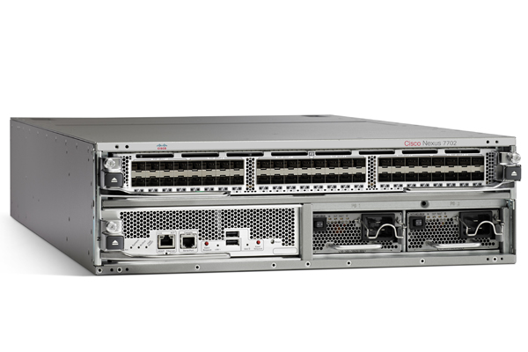](https://www.cisco.com/c/en/us/products/switches/nexus-7700-2-slot-switch/index.html)

In slot 1 we will install a 24 x 40G line card and in slot 2 we will install a 48 x 10G line card :



#### New DC Sites

A specific multisite OTV architecture is used for interconnexion with stretched BD. Due to MAN dual plan architecture and for resiliency concern, logical urbanization of each NK7 node will be specific on each site used for Multisite OTV interconnexion. But physical cabling will remain the same.

**First Site** :



**Second Site** :



**Physical view** :



|  |  |  |  |  |
| --- | --- | --- | --- | --- |
| **Device A** | **Port** | **Device B** | **Port** | **Interface Type** |
| <Fabric Code>-N7K-<Site Code>-<Room Code>-200**1** | 1/1 | <Fabric Code>-**BRD**-<Site Code>-<Room Code>-0101 | 1/5 | QSFP-40/100-SRBD |
| 1/2 | <Fabric Code>-**BRD**-<Site Code>-<Room Code>-0201 | 1/2 | QSFP-40/100-SRBD |
| 1/3 | <Fabric Code>-**BRD**-<Site Code>-<Room Code>-0201 | 1/3 | QSFP-40/100-SRBD |
| 1/4 | <Fabric Code>-**BRD**-<Site Code>-<Room Code>-0101 | 1/4 | QSFP-40/100-SRBD |
| 2/1 | MAN PE1 – *Plane A  (OTV Overlay)* | TBD | TBD |
| 2/9 | MAN PE1 – *Plane A (Multisite OTV or workaround)* | TBD | TBD |
| 2/10 | MAN PE2 – *Plane B (Multisite OTV or workaround)* | TBD | TBD |
| Mgnt1 | OOB Switch | - | 1G RJ45 |
| Mgnt2 | OOB Switch | - | 1G RJ45 |
| Con1 | - | - | Serial 9600 RJ45 |
| Con2 | - | - | Serial 9600 RJ45 |
|  |  |  |  |  |
| <Fabric Code>-N7K-<Site Code>-<Room Code>-200**2** | 1/1 | <Fabric Code>-**BRD**-<Site Code>-<Room Code>-0201 | 1/5 | QSFP-40/100-SRBD |
| 1/2 | <Fabric Code>-**BRD**-<Site Code>-<Room Code>-0101 | 1/2 | QSFP-40/100-SRBD |
| 1/3 | <Fabric Code>-**BRD**-<Site Code>-<Room Code>-0101 | 1/3 | QSFP-40/100-SRBD |
| 1/4 | <Fabric Code>-**BRD**-<Site Code>-<Room Code>-0201 | 1/4 | QSFP-40/100-SRBD |
| 2/1 | MAN PE2 – *Plane B  (OTV Overlay)* | TBD | TBD |
| 2/9 | MAN PE2 – *Plane B (Multisite OTV or workaround)* | TBD | TBD |
| 2/10 | MAN PE1 – *Plane A (Multisite OTV or workaround)* | TBD | TBD |
| Mgnt1 | OOB Switch | - | 1G RJ45 |
| Mgnt2 | OOB Switch | - | 1G RJ45 |
| Con1 | - | - | Serial 9600 RJ45 |
| Con2 | - | - | Serial 9600 RJ45 |

#### Legacy DC Sites

On each legacy DC site an OTV interconnexion infrastructure made up of 2 Nexus 7K node will be achieved.



|  |  |  |  |  |
| --- | --- | --- | --- | --- |
| **Device A** | **Port** | **Device B** | **Port** | **Interface Type** |
| <Fabric Code>-N7K-<Site Code>-<Room Code>-200**3** | 1/1 | DC LAN Switch 1 (Legacy) | TBD | 10G SFP |
| 1/2 | DC LAN Switch 2 (Legacy) | TBD | 10G SFP |
| 1/3 | MAN PE1 – *Plane A  (OTV Overlay)* | TBD | 10G SFP |
| 1/9 | DC LAN Switch 1 (Legacy) | TBD | 10G SFP |
| 1/10 | DC LAN Switch 2 (Legacy) | TBD | 10G SFP |
| 1/11 | MAN PE1 – *Plane A (Multisite OTV)* | TBD | 10G SFP |
| Mgnt1 | OOB Switch | - | 1G RJ45 |
| Mgnt2 | OOB Switch | - | 1G RJ45 |
| Con1 | - | - | Serial 9600 RJ45 |
| Con2 | - | - | Serial 9600 RJ45 |
|  |  |  |  |  |
| <Fabric Code>-N7K-<Site Code>-<Room Code>-200**4** | 1/1 | DC LAN Switch 1 (Legacy) | TBD | 10G SFP |
| 1/2 | DC LAN Switch 2 (Legacy) | TBD | 10G SFP |
| 1/3 | MAN PE2 – *Plane B  (OTV Overlay)* | TBD | 10G SFP |
| 1/9 | DC LAN Switch 1 (Legacy) | TBD | 10G SFP |
| 1/10 | DC LAN Switch 2 (Legacy) | TBD | 10G SFP |
| 1/11 | MAN PE2 – *Plane B (Multisite OTV)* | TBD | 10G SFP |
| Mgnt1 | OOB Switch | - | 1G RJ45 |
| Mgnt2 | OOB Switch | - | 1G RJ45 |
| Con1 | - | - | Serial 9600 RJ45 |
| Con2 | - | - | Serial 9600 RJ45 |

### APIC nodes

N9K-C93180YC-FX leaf switches are used to connect APIC nodes.

This is a 48 ports 10G-T and 6 ports 100G QSFP.

|  |  |  |  |  |
| --- | --- | --- | --- | --- |
| **Device A (APIC)** | **Port** | **Device B** | **Port** | **Interface Type** |
| <Fabric Code>-**APC**-<Site Code>-<Room Code>-0001 | 2/1 | <Fabric Code>-**SRV**-<Site Code>-<Room Code>-0**1**0**2** | 1/44 | SFP-10G-SR-S |
| 2/2 | <Fabric Code>-**SRV**-<Site Code>-<Room Code>-0**2**0**2** | 1/44 | SFP-10G-SR-S |
| Mgnt 1/1 | OOB Switch | - | 1G RJ45 |
| Mgnt 1/2 | OOB Switch | - | 1G RJ45 |
| CIMC | - | - | 1G RJ45 |

|  |  |  |  |  |
| --- | --- | --- | --- | --- |
| **Device A (APIC)** | **Port** | **Device B** | **Port** | **Interface Type** |
| <Fabric Code>-**APC**-<Site Code>-<Room Code>-0002 | 2/1 | <Fabric Code>-**SRV**-<Site Code>-<Room Code>-0**1**0**2** | 1/45 | SFP-10G-SR-S |
| 2/2 | <Fabric Code>-**SRV**-<Site Code>-<Room Code>-0**2**0**2** | 1/45 | SFP-10G-SR-S |
| Mgnt 1/1 | OOB Switch | - | 1G RJ45 |
| Mgnt 1/2 | OOB Switch | - | 1G RJ45 |
| CIMC | - | - | 1G RJ45 |

|  |  |  |  |  |
| --- | --- | --- | --- | --- |
| **Device A (APIC)** | **Port** | **Device B** | **Port** | **Interface Type** |
| <Fabric Code>-**APC**-<Site Code>-<Room Code>-0003 | 2/1 | <Fabric Code>-**SRV**-<Site Code>-<Room Code>-0**1**0**2** | 1/46 | SFP-10G-SR-S |
| 2/2 | <Fabric Code>-**SRV**-<Site Code>-<Room Code>-0**2**0**2** | 1/46 | SFP-10G-SR-S |
| Mgnt 1/1 | OOB Switch | - | 1G RJ45 |
| Mgnt 1/2 | OOB Switch | - | 1G RJ45 |
| CIMC | - | - | 1G RJ45 |

|  |  |  |  |  |
| --- | --- | --- | --- | --- |
| **Device A (APIC)** | **Port** | **Device B** | **Port** | **Interface Type** |
| <Fabric Code>-**APC**-<Site Code>-<Room Code>-0004 | 2/1 | <Fabric Code>-**SRV**-<Site Code>-<Room Code>-0**1**0**2** | 1/47 | SFP-10G-SR-S |
| 2/2 | <Fabric Code>-**SRV**-<Site Code>-<Room Code>-0**2**0**2** | 1/47 | SFP-10G-SR-S |
| Mgnt 1/1 | OOB Switch | - | 1G RJ45 |
| Mgnt 1/2 | OOB Switch | - | 1G RJ45 |
| CIMC | - | - | 1G RJ45 |

|  |  |  |  |  |
| --- | --- | --- | --- | --- |
| **Device A (APIC)** | **Port** | **Device B** | **Port** | **Interface Type** |
| <Fabric Code>-**APC**-<Site Code>-<Room Code>-0005 | 2/1 | <Fabric Code>-**SRV**-<Site Code>-<Room Code>-0**1**0**2** | 1/48 | SFP-10G-SR-S |
| 2/2 | <Fabric Code>-**SRV**-<Site Code>-<Room Code>-0**2**0**2** | 1/48 | SFP-10G-SR-S |
| Mgnt 1/1 | OOB Switch | - | 1G RJ45 |
| Mgnt 1/2 | OOB Switch | - | 1G RJ45 |
| CIMC | OOB Switch | - | 1G RJ45 |

### MSC physical nodes

One MSC Physical Nodes is hosted on OOB network on each site and are shared between all fabrics.

One MSC Virtual Instance is

|  |  |  |  |
| --- | --- | --- | --- |
| Datacenter | Site Code | Room | Site ID |
| Marcoussis DC2 | DC2 | - | - |
| Marcoussis DB2 | DB2 | - | - |
| Marcoussis DC5 | DC5 | 5B1 | SVR-MSC-DC5-5B1-0001 |
| Equinix Pantin | PAN | DH15 | SVR-MSC-PAN-DH15-0001 |
| Seclin 2 | SC2 | ??? | SVR-MSC-SC2-XXX-0001 |
| Marcoussis DCX | DCX | - | - |

|  |  |  |  |  |
| --- | --- | --- | --- | --- |
| **Device A (MSC)** | **Port** | **Device B** | **Port** | **Interface Type** |
| SVR-**MSC**-<Site Code>-<Room Code>-0001 | Mgnt | OOB Switch | - | 1G RJ45 |
| CIMC | - | - | 1G RJ45 |

### MSC virtual nodes

3 MSC instances will be deployed for each fabric :

* <Fabric Code>-**MSC**-<Site Code>-<Room Code>-0011
* <Fabric Code>-**MSC**-<Site Code>-<Room Code>-0012
* <Fabric Code>-**MSC**-<Site Code>-<Room Code>-0013

|  |  |  |
| --- | --- | --- |
| Multi-Site Fabric Controller | Site | Node ID |
| **ALD** | **DC5** | **0011** |
| **PAN** | **0012** |
| **SC2** | **0013** |
| **ASSU** | **DC5** | **0012** |
| **PAN** | **0013** |
| **SC2** | **0011** |
| **BDDF** | **DC5** | **0013** |
| **PAN** | **0011** |
| **SC2** | **0012** |
| **MARKET** | **DC5** | **0011** |
| **PAN** | **0012** |
| **SC2** | **0013** |
| **PLATFORM** | **DC5** | **0012** |
| **PAN** | **0013** |
| **SC2** | **0011** |

PS : The minimum specifications for Multi-Site virtual machines are ESXi 6.0 or later, minimum of 6 vCPUs (8 vCPUs recommended), 24 GB of RAM, and a 100 GB disk.

# Default QoS setup

ACI fabric will be configured to preserve ingress dot1q pbit and IP DSCP for traffic received from MAN or from servers.

3 level of class of service will be configured :

* Level 1 User Data : Real Time : 10% of allocated bandwidth in strict priority
* Level 2 User Data : Business Critical 60% of allocated bandwidth
* Level 3 User Data : Best Effort – use remaining available bandwidth

Following default mapping will be enforced for incoming IP traffic :

|  |  |  |
| --- | --- | --- |
| DSCP Code | Decimal Value | CoS mapping |
| CS7 | 56 | Level 1 |
| CS6 | 48 |
| CS5 | 40 |
| EF | 46 |
| CS4 | 32 | Level 2 |
| AF41 | 34 |
| AF42 | 36 |
| AF43 | 38 |
| CS3 | 24 |
| AF31 | 26 |
| AF32 | 28 |
| AF33 | 30 |
| CS2 | 16 |
| AF21 | 18 |
| AF22 | 20 |
| AF23 | 22 |
| CS1 | 8 | Level 3 |
| AF11 | 10 |
| AF12 | 12 |
| AF13 | 14 |
| CS0 / BE | 0 |

Following default mapping will be enforced for incoming Ethernet **not IP** traffic :

|  |  |
| --- | --- |
| pbit | CoS mapping |
| 7 | Level 1 |
| 6 |
| 5 |
| 4 | Level 2 |
| 3 |
| 2 |
| 1 | Level 3 |
| 0 |

# Maintenance groups

Maintenance Group policies define a group of switches that will be jointly upgraded to the associated firmware set. Maintenance groups can be upgraded on demand or according to a schedule, making it possible to defer an upgrade task to a business maintenance window.

Configured under: Admin 🡪 Firmware 🡪 Fabric Node Firmware 🡪 Maintenance Group

In Société Générale’s environment, two (2) maintenance groups will be recommended for the leaf switches. For example, one containing all devices with a Node ID starting with a ‘1’ and one with all devices with a Node ID starting with a ‘2’. Since there are three (3) spine switches, the recommendation is to use a separate maintenance group for each one.

Table 1: Maintenance Groups

|  |  |  |  |
| --- | --- | --- | --- |
| Maintenance Group Name | Run Mode | Group Node ID | Scheduler |
| NODES_<ODD_GRP_NODE_ID> | Pause upon upgrade failure | 1XX, 3XX, 5XX | none |
| NODES_<EVEN_GRP_NODE_ID> | Pause upon upgrade failure | 2XX, 4XX, 6XX | none |
| NODES_<GRP_NODE_ID> | Pause upon upgrade failure | 7XX, 8XX | none |
| SPINE_1001 | Pause upon upgrade failure | 1001 | none |
| SPINE_1002 | Pause upon upgrade failure | 1002 | none |
| SPINE_1003 | Pause upon upgrade failure | 1003 | none |

In the table below we have the details of each per entity LEAF nodes maintenance group :

|  |  |  |
| --- | --- | --- |
| Fabric Code | Tenant Name | Leaf Nodes Maintenance Group |
| ASU | ASSU | NODES_1XX; NODES_2XX; NODES_3XX; NODES_4XX; NODES_5XX; NODES_6XX; NODES_7XX; NODES_8XX; NODES_9XX; |
| RET | BDDF  CDN  BSC | NODES_1XX; NODES_2XX; NODES_3XX; NODES_4XX; NODES_5XX; NODES_6XX; NODES_7XX; NODES_8XX; NODES_9XX; |
| ALD | ALD | NODES_1XX; NODES_2XX; NODES_3XX; NODES_4XX; NODES_5XX; NODES_6XX; NODES_7XX; NODES_8XX; NODES_9XX; |
| MKT | SGCIB  SGSS  CGA | NODES_1XX; NODES_2XX; NODES_3XX; NODES_4XX; NODES_5XX; NODES_6XX; NODES_7XX; NODES_8XX; NODES_9XX; |
| PLT | CLOUD  WORKPLACE  BIGDATA  SHARED | NODES_1XX; NODES_2XX; NODES_3XX; NODES_4XX; NODES_5XX; NODES_6XX; NODES_7XX; NODES_8XX; NODES_9XX; |

# Generic Setup

## Syslog

|  |  |
| --- | --- |
| Object Name | TACACS parameters |
| SG-SYSLOG-SPLUNK | IP Address : 192.80.10.175 |

## SNMP

|  |  |
| --- | --- |
| Object Name | SNMP parameters |
| SG-SNMP-SPECTRUM-PRI | Version: 2c  Location: <Location Sentence>  Contact: <Location Sentence>  RO Community: AKe8Tp4  ALLOWED_RO_NET : <Management Network>  RW Community: BKe8Tp4  ALLOWED_RW_NET : : <Management Network>  SNMP Trap : AKe8Tp4  IP Address : 192.64.10.135  ALLOWED_RO_NET |
| SG-SNMP-SPECTRUM-SEC | Version: 2c  Location: <Location Sentence>  Contact: <Location Sentence>  RO Community: AKe8Tp4  ALLOWED_RO_NET : <Management Network>  RW Community: BKe8Tp4  ALLOWED_RW_NET : : <Management Network>  SNMP Trap : AKe8Tp4  IP Address : 192.80.10.135 |
| SG-NETSHOT | Version: 2c  Location: <Location Sentence>  Contact: <Location Sentence>  RO Community: AKe8Tp4  ALLOWED_RO_NET : <Management Network>  RW Community: BKe8Tp4  ALLOWED_RW_NET : : <Management Network>  SNMP Trap : Netsh01  IP Address : 192.80.10.182 |

<Contact Sentence> : « SG Network Team - +33.142131470 »

<Management Network> : <SUB_CAZA_TIG>, <SUB_CAZA_SC2>, <SUB_CAZA_DC2>

* <SUB_CAZA_TIG> : 192.64.10.0/24
* <SUB_CAZA_SC2> : 192.80.10.0/24
* <SUB_CAZA_DC2> : 192.88.10.0/24

<Location Sentence> :   
<Region>|<Site>|<Infra>|<Environment>|LAN_DC |<Switch type>|<Floor Level>|<Room>|<Rack Number>

With

* <Region> : FR
* <Site> : DC2, DB2, DC5, PAN, DC2
* <Infra> : ACI_<Fabric Code>
* <Environment> : PROD or DEV (Always PROD for ACI)
* <Switch type> : ACI_FABRIC
* <Floor Level> : Not relevant for ACI
* <Room> : Not relevant for ACI
* <Rack Number> : Not relevant for ACI

|  |  |
| --- | --- |
| Multi-Site Fabrics | Fabric Code |
| ASSU | ASU |
| RETAIL | RET |
| ALD | ALD |
| MARKET | MKT |
| PLATFORM | PLT |

<Location Sentence> for ACI Project :

FR|<Site>|ACI_<Fabric Code>|PROD[LAN_DC|ACI_FABRIC|-|-|-

**Example**: Platform ACI POD on DC5

FR|DC5|ACI_PLT|PROD[LAN_DC|ACI_FABRIC|-|-|-

## NTP

|  |  |
| --- | --- |
| Object Name | NTP parameters |
| SG-NTP | Primary IP address : 192.64.10.129  Secondary IP address : 192.80.10.129 |

## AAA

|  |  |
| --- | --- |
| Object Name | TACACS parameters |
| SG-TACACS | Primary IP address : 192.80.10.160  Secondary IP address : 192.88.10.160  Tacacs Key: <6gJ&Ty4 |